Online Supplements

eFigure 1
eFigure 2
eFigure 3
eFigure 4
eFigure 5
eFigure 6
eFigure 7
eTable 1
eTable 2
eTable 3
eTable 4

eFigure 1 Summary of previous studies of socioeconomic position and different intervals between symptom onset and diagnosis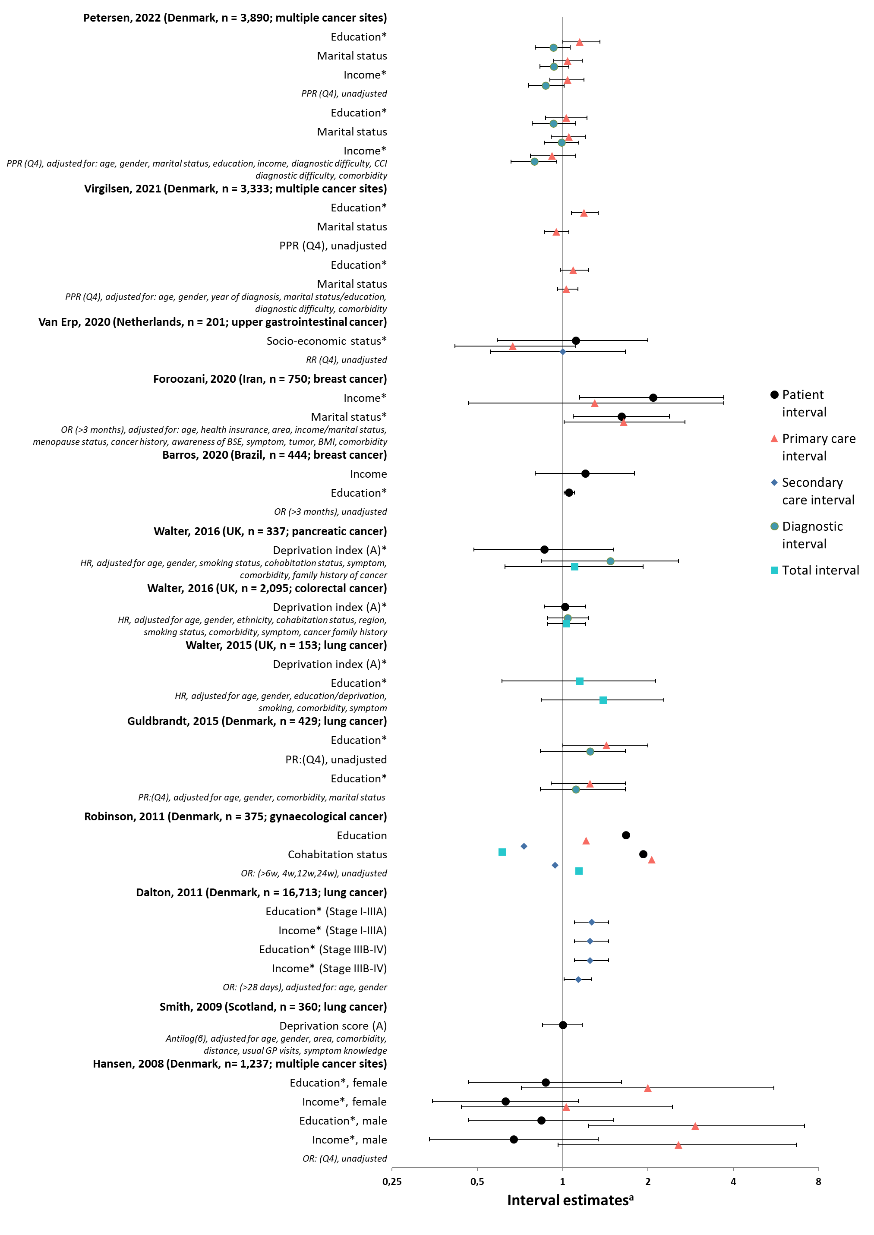
ª Interval estimates are provided for patients with low compared to high socioeconomic position. Please notice that outcome measures and adjustments vary across studies, as provided in italics below the related estimates. *denotes that the reference group has been converted (1/estimate) in order to illustrate trends

eFigure 2 Flowchart illustrating inclusion and exclusion of patients in the study

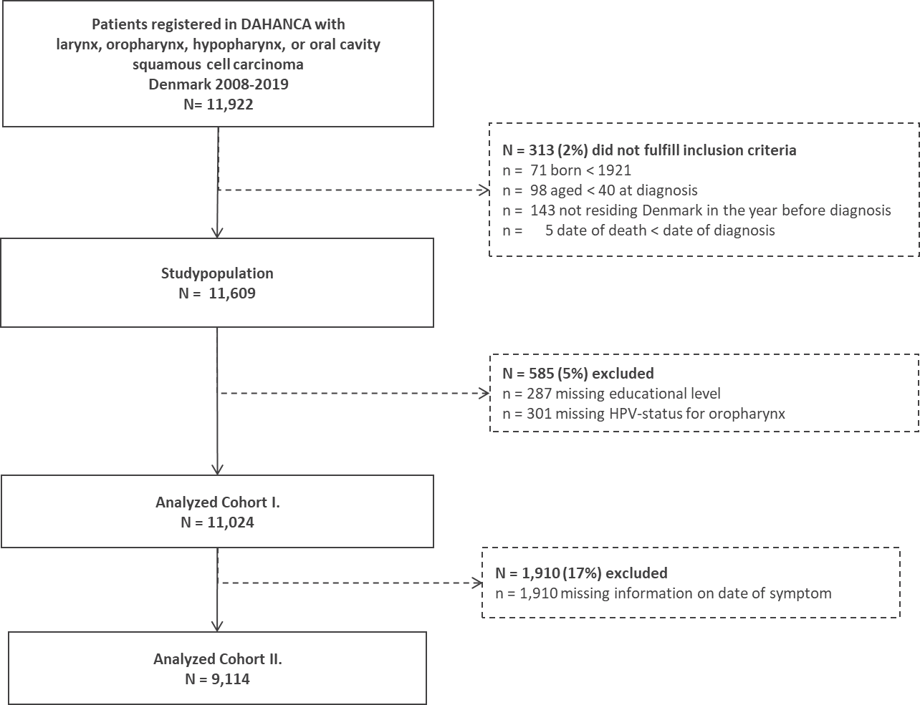

eFigure 3 Simplistic illustration of hypothesized associations between socioeconomic position (SEP) and the interval from symptom onset to diagnosis (outcome I), consultation patters prior to diagnosis (outcome II) and disease stage at diagnosis (outcome III)

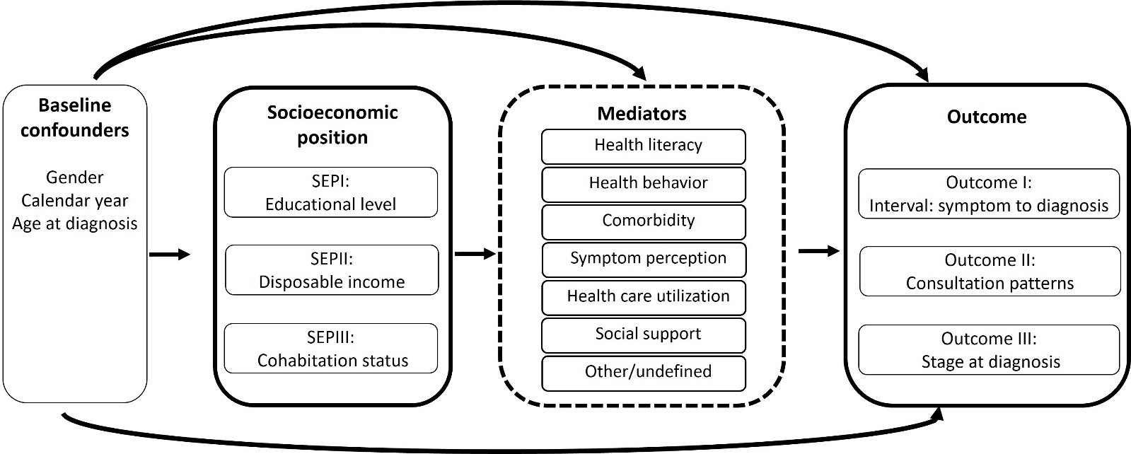

eFigure 4 Adjusted estimates with 95% confidence intervals for the association between educational level
and the interval between symptom onset and diagnosis, stratified by days since diagnosis, age, gender, year of diagnosis, comorbidity score (HN-CCI), symptom or subsite

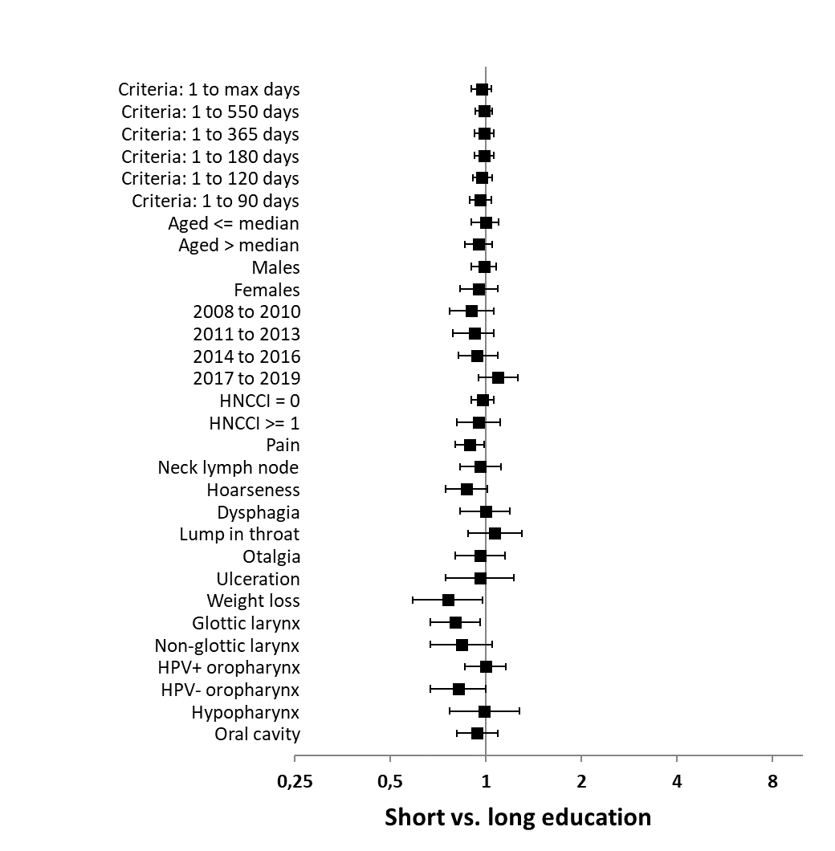
Estimate with 95% confidence intervals, adjusted for age (cont.), gender, calendar year (cont.)
HPV = human papillomavirus, HN-CCI = Revised Charlson Comorbidity Index for Head and Neck Cancer

eFigure 5 Adjusted estimates with 95% confidence intervals for the association between educational level
and the interval between symptom onset and diagnosis, by subsite, stratified by days since diagnosis, age, gender, year of diagnosis, comorbidity score (HN-CCI) or symptom

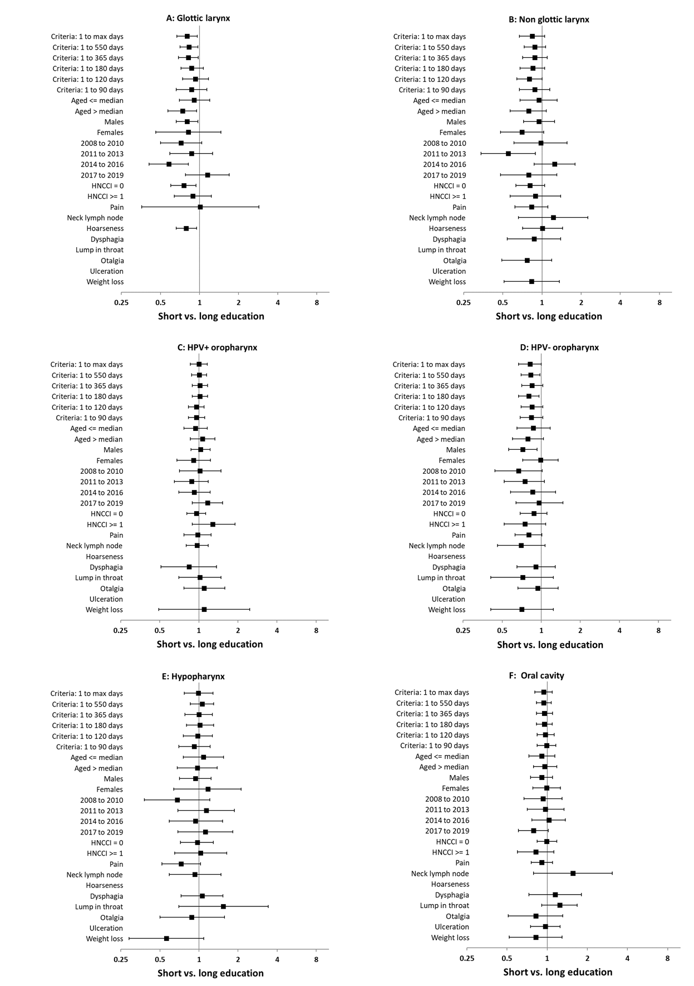
Estimate with 95% confidence intervals, adjusted for age (cont.), gender, calendar year (cont.)
HPV = human papillomavirus, HN-CCI = Revised Charlson Comorbidity Index for Head and Neck Cancer
eFigure 6 Median interval and IQR between patient-reported symptom onset and diagnosis and change-point for which the average number for consultations changed, by educational level within strata of age, gender and symptom presentation

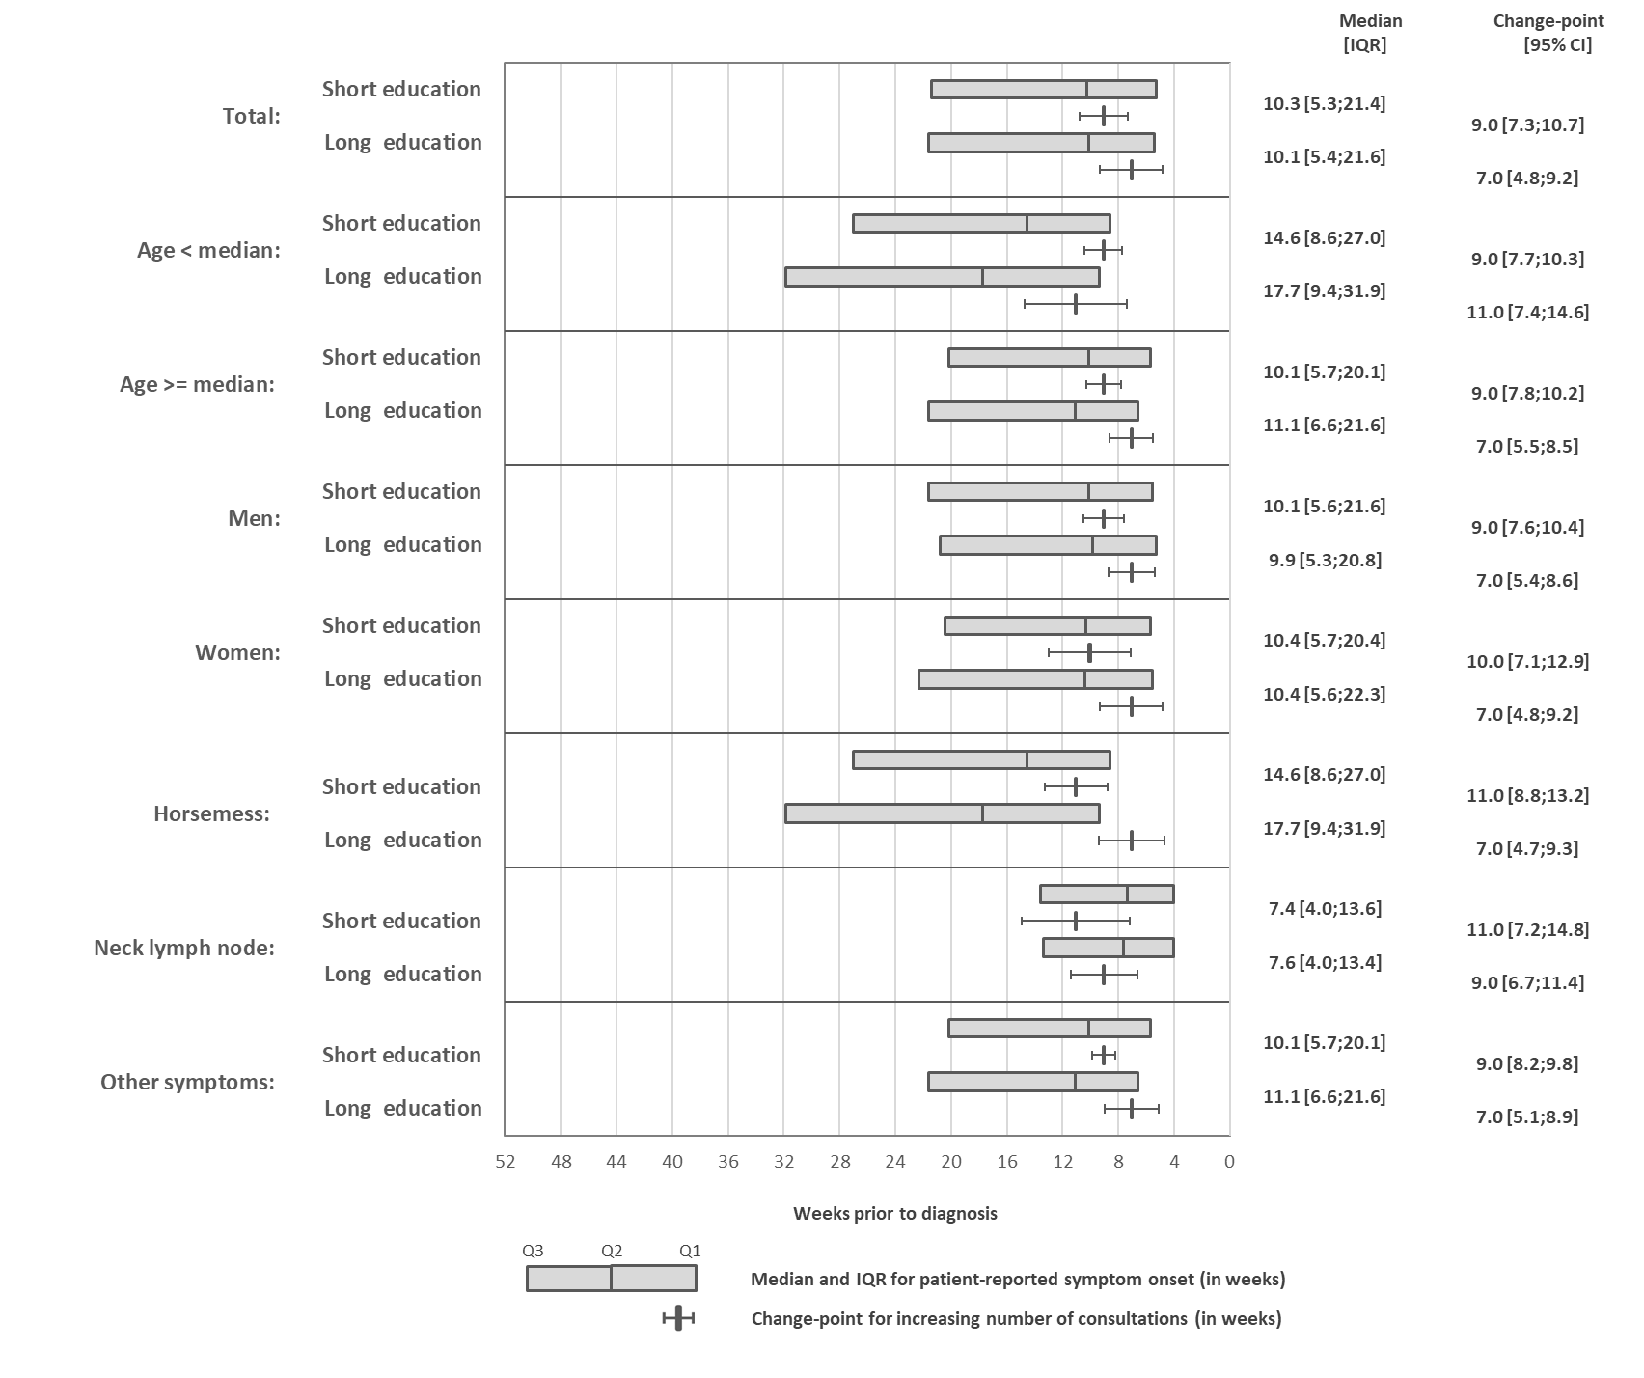
IQR: Interquartile range
CI: 95% confidence intervals

eFigure 7 Median interval and IQR between patient-reported symptom onset and diagnosis and change-point for which the average weekly number of consultations changed, by educational level within quintiles of the interval from symptom onset to diagnosis
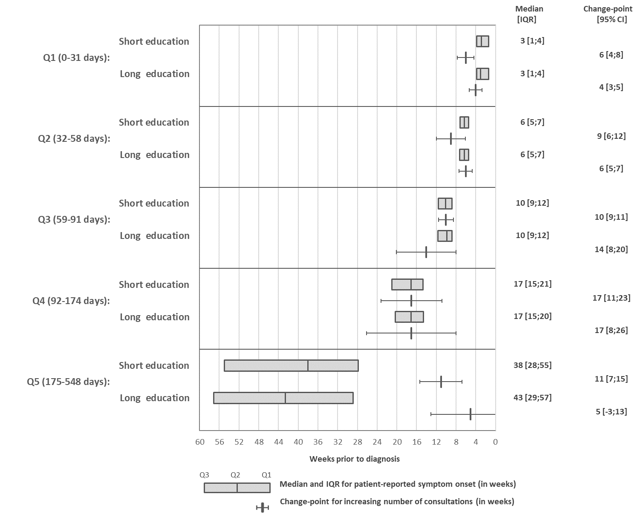IQR: Interquartile range
CI: 95% confidence intervals

eTable 1 Predefined list of symptoms and the number of primary symptoms reported by patients, for all sites combined and by subsite

 | All included sites | Glottic larynx | Non-glottic larynx | HPV+ oropharynx | HPV- oropharynx | Hypopharynx | Oral cavity
 | ( n = 10 000)ª | ( n = 1 579) | ( n = 869) | ( n = 2 483) | ( n = 1 454) | ( n = 971) | ( n = 2 644)
Primary symptoms | N (%) | N (%) | N (%) | N (%) | N (%) | N (%) | N (%)
Pain | 4 125 (41) | 98 (6) | 403 (46) | 858 (35) | 868 (60) | 480 (49) | 1 418 (54)
Neck lymph node | 2 166 (22) | 11 (1) | 90 (10) | 1 378 (55) | 324 (22) | 252 (26) | 111 (4)
Hoarseness | 2 153 (22) | 1 493 (95) | 405 (47) | 34 (1) | 34 (2) | 176 (18) | 11 ()
Dysphagia | 1 417 (14) | 30 (2) | 192 (22) | 259 (10) | 369 (25) | 382 (39) | 185 (7)
Lump in throat (globus sensation) | 1 273 (13) | 7 () | 59 (7) | 341 (14) | 169 (12) | 79 (8) | 618 (23)
Otalgia | 1 092 (11) | 35 (2) | 129 (15) | 327 (13) | 275 (19) | 180 (19) | 146 (6)
Ulceration | 931 (9) | NA | NA | 26 (1) | 73 (5) | NA | 825 (31)
Weight loss | 793 (8) | 27 (2) | 104 (12) | 111 (4) | 186 (13) | 154 (16) | 211 (8)
Bleeding | 196 (2) | 8 (1) | 15 (2) | 67 (3) | 23 (2) | 25 (3) | 58 (2)
Coughing | 166 (2) | 42 (3) | 41 (5) | 27 (1) | NA | 39 (4) | NA
Respiratory insufficiency | 142 (1) | 45 (3) | 44 (5) | 11 () | NA | 36 (4) | NA
Weak voice | 29 () | 8 (1) | NA | NA | 7 () | 8 (1) | NA
Sinusitis | 17 () | NA | NA | 7 () | NA | NA | NA
Hearing impairment (hypacusis) | 14 () | NA | NA | 7 () | NA | NA | NA
Cranial nerve palsy | 10 () | NA | NA | NA | NA | NA | NA
Vocal fatigue | 10 () | NA | NA | NA | NA | NA | NA
No symptoms | 271 (3) | 20 (1) | 13 (1) | 49 (2) | 43 (3) | 16 (2) | 130 (5)
Other symptoms | 457 (5) | 30 (2) | 25 (3) | 118 (5) | 53 (4) | 39 (4) | 192 (7)
NA = number not applied because of microdata (n<5 observations) across strata
ª The number of patients in this table is 10 000 as it is based on analyzed cohort I (N=11 024) except for patients with missing information on primary symptoms (N=1 024)).

eTable 2 Unadjusted median interval between reported symptom onset and date of diagnosis (in weeks)
 | All included sites | Glottic larynx | Non-glottic larynx | HPV+ oropharynx | HPV- oropharynx | Hypopharynx | Oral cavity
 | ( n = 9 114) | ( n = 1 422) | (n = 803) | (n= 2 313) | ( n = 1 350) | ( n = 896) | ( n = 2 330)
Parameter | Median [IQR] | Median [IQR] | Median [IQR] | Median [IQR] | Median [IQR] | Median [IQR] | Median [IQR]
Total | 10 [5;21] | 15 [8;29] | 12 [7;21] | 8 [4;16] | 9 [5;17] | 11 [6;21] | 10 [5;21]
Age
Q1: 40-56 | 10 [5;20] | 15 [8;28] | 13 [8;22] | 8 [4;15] | 9 [5;17] | 11 [6;22] | 12 [6;25]
Q2: 57-63 | 10 [5;21] | 16 [9;29] | 11 [7;19] | 9 [4;17] | 9 [6;18] | 12 [7;22] | 10 [5;20]
Q3: 64-70 | 10 [5;21] | 16 [9;29] | 12 [7;21] | 9 [4;16] | 8 [5;15] | 11 [6;23] | 10 [5;20]
Q4: 71-96 | 11 [5;22] | 15 [8;29] | 12 [6;21] | 8 [4;18] | 10 [5;18] | 10 [6;17] | 9 [5;19]
Gender
Female | 11 [6;22] | 15 [8;29] | 13 [7;23] | 9 [5;19] | 9 [5;17] | 13 [6;26] | 11 [6;23]
Male | 10 [5;21] | 16 [9;29] | 11 [7;21] | 8 [4;15] | 9 [5;17] | 10 [6;19] | 9 [5;20]
Period of diagnosis
2008−2010 | 12 [7;23] | 17 [9;32] | 12 [8;23] | 10 [6;19] | 9 [5;17] | 12 [7;22] | 11 [6;23]
2011−2013 | 10 [5;20] | 15 [8;28] | 12 [6;22] | 9 [5;18] | 9 [5;17] | 10 [5;20] | 9 [5;18]
2014−2016 | 10 [5;20] | 15 [8;28] | 13 [7;21] | 8 [4;15] | 9 [5;18] | 10 [5;19] | 9 [4;20]
2017−2019 | 10 [5;20] | 16 [8;28] | 11 [6;17] | 7 [4;14] | 9 [5;16] | 12 [7;23] | 10 [5;21]
Educational level
Short | 10 [5;22] | 15 [9;29] | 12 [7;22] | 8 [4;16] | 8 [4;15] | 12 [6;22] | 10 [5;21]
Medium | 10 [5;20] | 15 [8;28] | 11 [7;21] | 8 [4;16] | 9 [5;17] | 10 [6;21] | 10 [5;21]
Long | 10 [5;22] | 19 [10;33] | 13 [8;23] | 8 [4;15] | 9 [6;18] | 10 [6;19] | 10 [6;22]
Income
Low | 11 [6;22] | 16 [8;31] | 12 [7;21] | 9 [5;19] | 9 [5;17] | 11 [6;22] | 10 [5;21]
Medium | 10 [5;20] | 15 [9;28] | 12 [7;21] | 8 [4;16] | 9 [5;17] | 10 [5;20] | 10 [5;20]
High | 10 [5;20] | 17 [9;29] | 13 [8;21] | 8 [4;15] | 10 [6;18] | 11 [7;19] | 10 [5;22]
Cohabiting status
Living alone | 10 [6;21] | 16 [8;29] | 12 [7;21] | 8 [4;16] | 9 [5;17] | 12 [6;22] | 10 [5;21]
Cohabiting | 10 [5;20] | 15 [9;29] | 12 [7;21] | 8 [4;16] | 9 [5;17] | 10 [6;20] | 10 [5;21]

eTable 2 [cont.]
Comorbidity
HN-CCI >= 1 | 10 [5;21] | 17 [9;30] | 11 [6;18] | 8 [4;17] | 9 [5;17] | 10 [5;22] | 9 [5;18]
HN-CCI = 0 | 10 [5;21] | 15 [8;28] | 13 [8;23] | 8 [4;16] | 9 [5;17] | 11 [6;21] | 10 [5;22]
Primary symptomsª
Pain | 11 [6;21] | NA | 12 [8;21] | 10 [5;19] | 10 [6;18] | 12 [7;22] | 10 [6;21]
No Pain | 10 [5;21] | NA | 11 [7;21] | 7 [4;14] | 8 [4;16] | 10 [5;19] | 9 [4;21]
Neck lymph node | 7 [4;13] | NA | NA | 7 [4;13] | 7 [4;13] | 8 [4;14] | NA
No neck lymph node | 11 [6;23] | NA | NA | 10 [5;20] | 9 [6;18] | 12 [7;23] | NA
Hoarseness | 14 [8;27] | 16 [9;29] | 12 [8;22] | NA | NA | NA | NA
No hoarseness | 9 [5;18] | 11 [6;26] | 12 [6;19] | NA | NA | NA | NA
Dysphagia | 12 [7;23] | NA | 12 [7;21] | 11 [5;22] | 12 [7;23] | 13 [8;25] | NA
No dysphagia | 10 [5;20] | NA | 12 [7;21] | 8 [4;15] | 8 [4;15] | 9 [5;17] | NA
Lump in throat | 9 [5;20] | NA | NA | 9 [5;19] | 8 [5;16] | NA | 9 [5;21]
No lump in throat | 10 [5;21] | NA | NA | 8 [4;16] | 9 [5;17] | NA | 10 [5;21]
Otalgia | 11 [6;21] | NA | 13 [8;20] | 12 [6;24] | 10 [6;17] | 12 [6;22] | NA
No otalgia | 10 [5;21] | NA | 12 [7;21] | 8 [4;15] | 9 [5;17] | 10 [6;20] | NA
Ulceration | 10 [5;21] | NA | NA | NA | NA | NA | 10 [5;21]
No ulceration | 10 [5;21] | NA | NA | NA | NA | NA | 10 [5;21]
Weight loss | 12 [7;25] | NA | 14 [9;21] | NA | 12 [7;22] | NA | 11 [7;22]
No weight loss | 10 [5;21] | NA | 12 [7;21] | NA | 9 [5;17] | NA | 10 [5;21]
HPV = human papillomavirus, IQR = Interquartile range, HN-CCI = Revised Charlson Comorbidity Index for Head and Neck Cancer, NA: Not applicable because of micro data (n<5 observations)
ª Frequently reported symptoms according to the predefined list provided in eTable1 (not all symptoms are applied because of micro-data in strata)

eTable 3 Adjusted odds ratios (ORs) with 95% confidence intervals (CIs) for advanced disease stage (TNM-8: III-IV vs. I-II), by subsite
 | All included sites | Glottic larynx | Non-glottic larynx | HPV+ oropharynx | HPV- oropharynx | Hypopharynx | Oral cavity
 | ORª [95% CI] | ORª [95% CI] | ORª [95% CI] | ORª [95% CI] | ORª [95% CI] | ORª [95% CI] | ORª [95% CI]
Educational level
Short | 1.71 [1.52;1.92] | 1.51 [1.01;2.25] | 0.82 [0.53;1.28] | 1.53 [1.08;2.18] | 1.23 [0.82;1.82] | 0.97 [0.45;2.08] | 1.74 [1.39;2.17]
Medium | 1.37 [1.24;1.52] | 1.18 [0.81;1.73] | 0.91 [0.59;1.39] | 1.09 [0.81;1.47] | 1.13 [0.8;1.61] | 0.57 [0.29;1.11] | 1.22 [1.00;1.48]
Long | 1.00 [Ref] | 1.00 [Ref] | 1.00 [Ref] | 1.00 [Ref] | 1.00 [Ref] | 1.00 [Ref] | 1.00 [Ref]
Income
Low | 2.15 [1.94;2.39] | 1.67 [1.18;2.38] | 1.38 [0.94;2.03] | 1.78 [1.31;2.42] | 0.98 [0.69;1.40] | 0.73 [0.38;1.39] | 1.56 [1.28;1.90]
Medium | 1.51 [1.38;1.66] | 1.66 [1.21;2.27] | 1.08 [0.76;1.52] | 1.02 [0.77;1.35] | 0.97 [0.70;1.34] | 0.65 [0.36;1.16] | 1.19 [1.00;1.42]
High | 1.00 [Ref] | 1.00 [Ref] | 1.00 [Ref] | 1.00 [Ref] | 1.00 [Ref] | 1.00 [Ref] | 1.00 [Ref]
Cohabitation status
Living alone | 1.88 [1.74;2.03] | 1.88 [1.47;2.41] | 1.33 [1.01;1.75] | 1.31 [1.02;1.68] | 1.17 [0.92;1.50] | 1.17 [0.78;1.75] | 1.59 [1.38;1.84]
Cohabiting | 1.00 [Ref] | 1.00 [Ref] | 1.00 [Ref] | 1.00 [Ref] | 1.00 [Ref] | 1.00 [Ref] | 1.00 [Ref]
Interval from reported symptom onset to diagnosis
Q1: | 1.00 [Ref] | 1.00 [Ref] | 1.00 [Ref] | 1.00 [Ref] | 1.00 [Ref] | 1.00 [Ref] | 1.00 [Ref]
Q2: | 1.10 [0.98;1.23] | 0.82 [0.55;1.22] | 0.90 [0.58;1.37] | 1.09 [0.74;1.6] | 1.01 [0.69;1.47] | 0.95 [0.51;1.75] | 1.29 [1.02;1.63]
Q3: | 1.12 [0.99;1.26] | 1.22 [0.84;1.79] | 0.91 [0.6;1.39] | 1.09 [0.74;1.6] | 1.05 [0.72;1.54] | 1.36 [0.7;2.65] | 1.4 [1.11;1.76]
Q4: | 1.09 [0.97;1.22] | 1.52 [1.05;2.2] | 0.64 [0.42;0.97] | 1.84 [1.29;2.62] | 0.85 [0.58;1.22] | 0.81 [0.45;1.48] | 1.12 [0.89;1.41]
ª Adjusted for age (cont.), gender, calendar year (cont.), patients with missing information on stage (n = 126) are excluded from the numbers provided in Table 1
HPV= human papillomavirus, HN-CCI = Revised Charlson Comorbidity Index for Head and Neck Cancer

eTable 4 Adjusted odds ratios (ORs) with 95% confidence intervals (CIs) for being excluded vs. included, by analyzed cohort
 | Analyzed cohort I |  |  |  | Analyzed cohort II
 | Included | Excluded | Adjusted OR |  | Included | Excluded | Adjsuted OR
 | ( n = 11 024) | ( n = 585) |  |  | ( n = 9 114) | ( n = 2 495)
Characteristics | N (%) | N (%) | OR^{e} (95 % CI) |  | OR (95 % CI) | N (%) | OR^{e} (95 % CI)
Age
Median [IQR] | 64 [57;71] | 62 [56;71] | 1.00 [0.99;1.01] |  | 65 [58;72] | 64 [57;70] | 1.02 [1.01;1.02]
Siteª
Glottic larynx | 1 722 (16%) | 47 (17%) | 1.32 [0.85;2.04] |  | 1 422 (16%) | 347 (16%) | 1.30 [1.06;1.59]
Non-glottic larynx | 968 (9%) | 30 (11%) | 1.52 [0.93;2.47] |  | 803 (9%) | 195 (9%) | 1.10 [0.86;1.42]
HPV+ oropharynx | 2 626 (24%) | 52 (18%) | 1.00 [ref] |  | 2 313 (25%) | 365 (17%) | 1.00 [ref]
HPV- oropharynx | 1 557 (14%) | 38 (13%) | 1.23 [0.79;1.91] |  | 1 350 (15%) | 245 (11%) | 1.03 [0.83;1.28]
Hypopharynx | 1 035 (9%) | 35 (12%) | 1.80 [1.15;2.81] |  | 896 (10%) | 174 (8%) | 1.17 [0.92;1.49]
Oral cavity | 3 116 (28%) | 82 (29%) | 1.39 [0.96;2.02] |  | 2 330 (26%) | 868 (40%) | 1.73 [1.45;2.05]
Gender
Female | 2 958 (27%) | 144 (25%) | 1.00 [ref] |  | 2 376 (26%) | 726 (29%) | 1.00 [ref]
Male | 8 066 (73%) | 441 (75%) | 1.11 [0.91;1.35] |  | 6 738 (74%) | 1 769 (71%) | 0.87 [0.79;0.96]
Period of diagnosis
2008−2010 | 2 353 (21%) | 215 (37%) | 1.83 [1.47;2.27] |  | 1 853 (20%) | 715 (29%) | 1.74 [1.53;1.97]
2011−2013 | 2 801 (25%) | 114 (20%) | 1.82 [0.63;1.05] |  | 2 302 (25%) | 613 (25%) | 1.18 [1.04;1.34]
2014−2016 | 2 941 (27%) | 111 (19%) | 0.76 [0.59;0.98] |  | 2 467 (27%) | 585 (23%) | 1.04 [0.92;1.18]
2017−2019 | 2 929 (27%) | 145 (25%) | 1.00 [ref] |  | 2 492 (27%) | 582 (23%) | 1.00 [ref]
Education^{b}
Short | 2 934 (27%) | 79 (15%) | 1.26 [0.85;1.85] |  | 2 432 (27%) | 581 (18%) | 0.92 [0.80;1.07]
Medium | 6 141 (56%) | 181 (34%) | 1.38 [0.98;1.96] |  | 5 083 (56%) | 1 239 (38%) | 1.00 [0.88;1.14]
Long | 1 949 (18%) | 40 (8%) | 1.00 [ref] |  | 1 599 (18%) | 390 (12%) | 1.00 [ref]
Income^{c}
Low | 3 009 (27%) | 181 (31%) | 1.24 [0.99;1.56] |  | 2 528 (28%) | 662 (27%) | 0.95 [0.84;1.07]
Medium | 4 873 (44%) | 251 (43%) | 1.10 [0.90;1.36] |  | 4 031 (44%) | 1 093 (44%) | 0.96 [0.86;1.06]
High | 3 142 (29%) | 148 (26%) | 1.00 [ref] |  | 2 555 (28%) | 735 (30%) | 1.00 [ref]
Cohabitation status^{c}
Living alone | 4 958 (45%) | 323 (56%) | 1.55 [1.31;1.83] |  | 4 043 (44%) | 1 238 (50%) | 1.22 [1.11;1.33]
Cohabiting | 6 066 (55%) | 257 (44%) | 1.00 [ref] |  | 5 071 (56%) | 1 252 (50%) | 1.00 [ref]
Primary symptoms^{d}
Missing information | 1 024 (9%) | 73 (12%) |  |  | 106 (1%) | 991 (40%)
Reported symptoms* | 10 000 (91%) | 512 (88%) |  |  | 9 008 (99%) | 1504 (60%)
Pain (% of*) | 4 125 (41%) | 229 (45%) | 1.14 [0.95;1.37] |  | 3 813 (42%) | 541 (36%) | 0.77 [0.68;0.86]
Neck lymph node (% of*) | 2 166 (22%) | 151 (29%) | 1.55 [1.27;1.89] |  | 2 038 (23%) | 279 (19%) | 0.84 [0.73;0.97]
Hoarseness (% of*) | 2 153 (22%) | 58 (11%) | 0.44 [0.33;0.58] |  | 1 959 (22%) | 252 (17%) | 0.67 [0.58;0.77]
Dysphagia (% of*) | 1 417 (14%) | 80 (16%) | 1.12 [0.88;1.44] |  | 1 317 (15%) | 180 (12%) | 0.80 [0.68;0.95]
Lump in throat (% of*) | 1 273 (13%) | 60 (12%) | 0.88 [0.67;1.16] |  | 1 155 (13%) | 178 (12%) | 0.89 [0.75;1.05]
Otalgia (% of*) | 1 092 (11%) | 57 (11%) | 1.03 [0.77;1.36] |  | 1 042 (12%) | 107 (7%) | 0.60 [0.49;0.74]
Ulceration (% of*) | 931 (9%) | 34 (7%) | 0.73 [0.51;1.04] |  | 826 (9%) | 139 (9%) | 1.01 [0.83;1.22]
Weight loss (% of*) | 793 (8%) | 42 (8%) | 1.03 [0.75;1.43] |  | 723 (8%) | 112 (7%) | 0.91 [0.74;1.12]
Comorbidity score
HN-CCI = 0 | 7 833 (71%) | 363 (62%) | 1.00 [ref] |  | 6 548 (72%) | 1 648 (66%) | 1.00 [ref]
HN-CCI ≥ 1 | 3 191 (29%) | 222 (38%) | 1.53 [1.29;1.82] |  | 2 566 (28%) | 847 (34%) | 1.27 [1.15;1.40]
ª N=301 with missing information on HPV status are excluded from this section
^{b} N=285 with missing information in the excluded cohorts are excluded in this section
^{c} N=5 with missing information are excluded in this section
^{d} According to the predefined list provided in eTable 1, the reference group for the OR in this section are patients not reporting the specific symptom
^{e} Adjusted for age (cont.), gender, calendar year (cont.), patients with missing information on stage (n = 126) are excluded from the numbers provided in Table 1

