Supplementary material

Table S1: Reference MRI sequence parameters*
 | TR [ms] | TE [ms] | FA [º] | Matrix size
MRI1 | 6.90 | 3.40 | 14 | 372 x 372 x 167
MRI2 | 6.90 | 3.40 | 14 | 372 x 372 x 187
MRI3 | 5.75 | 2.63 | 14 | 372 x 372 x 167
MRI4 | 5.75 | 2.63 | 14 | 372 x 372 x 167
MRI5 | 6.30 | 3.05 | 20 | 352 x 352 x 160
MRI6 | 11.0 | 4.10 | 35 | 352 x 352 x 160
MRI7 | 5.57 | 2.63 | 14 | 512 x 512 x 160
MRI8 | 5.75 | 2.63 | 14 | 372 x 372 x 173
MRL1 | 6.27 | 2.83 | 14 | 372 x 373 x 167
MRL2 | 13.0 | 6.23 | 14 | 200 x 200 x 160
MRL3 | 6.20 | 2.50 | 25 | 360 x 360 x 176
MRI Rad | 6.90 | 3.40 | 25 | 372 x 372 x 200
*MRI sequence parameters for the reference MRI sequence acquired on all investigated scanners. Adjustments were necessary due to differences in field strength and vendor-specific restrictions in settings. TR: repetition time, TE: echo time, FA: flip angle.

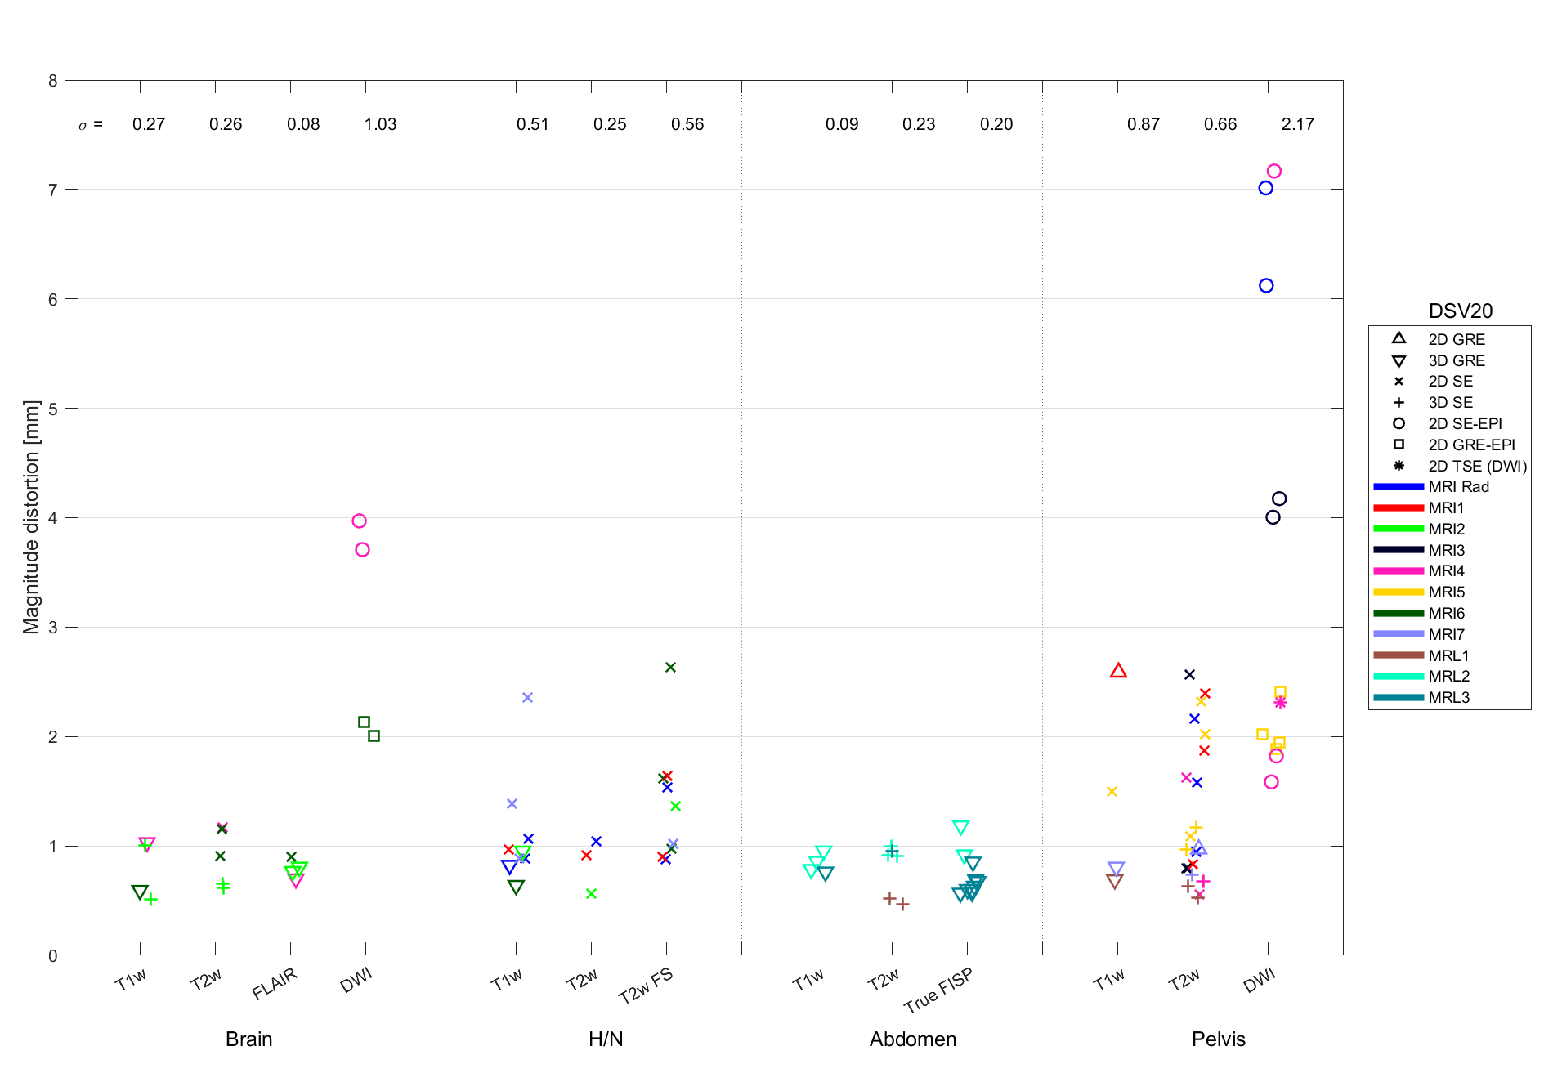
Figure S1) Magnitude distortion (in mm) within a spherical volume with a diameter of 20 cm (DSV20) for all clinical MRI sequences investigated. The MRI sequences are divided into anatomical sites (brain, head and neck (H/N), abdomen, pelvis) and sequence weightings representative for that anatomical site (e.g. T1w) on the x-axis. Marker color specifies MRI system, and marker type specifies MRI sequence types (gradient-recalled echo (GRE), spin-echo (SE), and echo-planar imaging (EPI)). σ denotes standard deviation within a sequence group.
Figure S2) Magnitude distortion (in mm) within a spherical volume with a diameter of 30 cm (DSV30) for all clinical MRI sequences investigated. The MRI sequences are divided into anatomical sites (brain, head and neck (H/N), abdomen, pelvis) and sequence weightings representative for that anatomical site (e.g. T1w) on the x-axis. Marker color specifies MRI system, and marker type specifies MRI sequence types (gradient-recalled echo (GRE), spin-echo (SE), and echo-planar imaging (EPI)). σ denotes standard deviation within a sequence group.

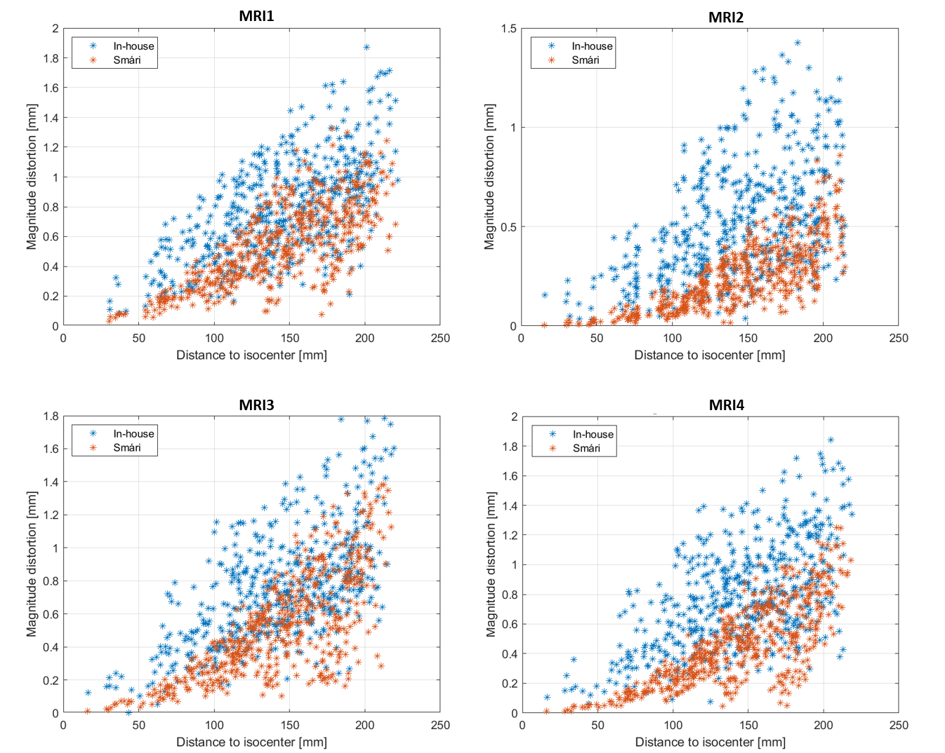
Figure S3) Geometric distortion as a function of distance to isocenter for the reference 3D T1w GRE sequence using the vendor-developed analysis tool Smári (red) and the in-house developed analysis tool (blue) for four MRI systems (MRI1-4).

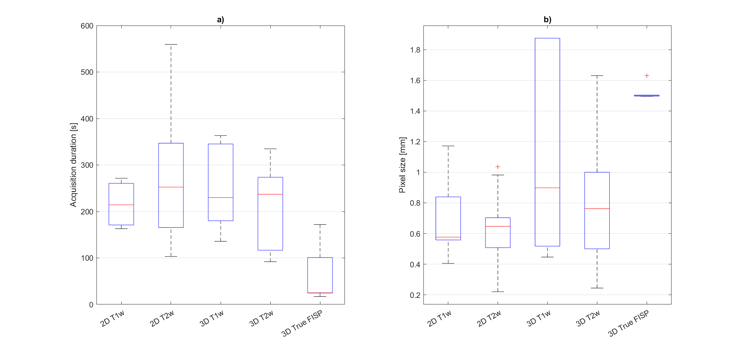Figure S4) Boxplot showing a) acquisition duration for 2D/3D T1w/T2w/True FISP acquisitions (DWI excluded), b) pixel size (all pixels are isotropic) for same sequences. Red lines show median values.

Table S2: MRI sequence parameters for all clinical MRI sequences investigated. TE: echo time, TR: repetition time, FA: flip angle, pBW: bandwidth pr. Pixel, NEX: number of excitations, SE: spin echo, GRE: gradient-recalled echo, DWI: diffusion-weighted imaging, EPI: echo planar imaging, Ax: axial, Cor: coronal, Sag: sagittal, Seq.: sequence. – indicates missing value.

Anatomy | Scanner | Seq. ID | Weighting | Seq. Type | 2D/3D | Direction | TE [ms] | TR [ms] | FA [º] | pBW [Hz/px] | Matrix size | Pixel size [mm²] | Slice Thickness [mm] | Slice  Gap [mm] | Num.  Of Slices | NEX | Acq. Dur. [s]
Brain | MRI4 | 1 | T1w | GRE | 3D | 3D | 3.8 | 25.0 | 30 | 190 | 232 x 232 | 0.96 x 0.96 | 2 | 0 | 154 | 2 | 354.3
Brain | MRI4 | 2 | DWI, b=0 | SE-EPI | 2D | Ax | 89.5 | 2944.0 | 90 | 1387 | 144 x 90 | 1.31 x 1.31 | 5 | 1 | 19 | 1 | 35.3
Brain | MRI4 | 2 | DWI, b=1000 | SE-EPI | 2D | Ax | 89.5 | 2944.0 | 90 | 1387 | 144 x 90 | 1.31 x 1.31 | 5 | 1 | 19 | 1 | 35.3
Brain | MRI4 | 3 | T2w | SE | 2D | Ax | 100.0 | 4444.3 | 90 | 145 | 384 x 300 | 0.48 x 0.48 | 5 | 1 | 22 | 2 | 146.7
Brain | MRI4 | 4 | FLAIR | GRE | 3D | 3D | 334.8 | 4800.0 | 90 | 855 | 232 x 230 | 0.72 x 0.72 | 3 | 0 | 44 | 3 | 264.0
Brain | MRI6 | 5 | T2w | SE | 2D | Ax | 93.0 | 7250.0 | 150 | 223 | 400 x 400 | 0.55 x 0.55 | 3 | 0.3 | 49 | 2 | -
Brain | MRI6 | 6 | T2w | SE | 2D | Cor | 93.0 | 6340.0 | 150 | 223 | 400 x 400 | 0.58 x 0.58 | 3 | 0.6 | 48 | 2 | -
Brain | MRI6 | 7 | FLAIR | SE | 2D | Ax | 75.0 | 7190.0 | 150 | 289 | 320 x 224 | 0.69 x 0.69 | 3 | 0.3 | 48 | 1 | -
Brain | MRI6 | 8 | T1w | GRE | 3D | 3D | 3.3 | 2400.0 | 8 | 279 | 256 x 256 | 0.90 x 0.90 | 0.9 | 0 | 224 | 1 | -
Brain | MRI6 | 9 | DWI, b=0 | GRE-EPI | 2D | Ax | 76.2 | 6290.0 | 180 | 868 | 160 x 160 | 0.69 x 0.69 | 4 | 1.2 | 27 | 1 | -
Brain | MRI6 | 9 | DWI, b=1000 | GRE-EPI | 2D | Ax | 76.2 | 6290.0 | 180 | 868 | 160 x 160 | 0.69 x 0.69 | 4 | 1.2 | 27 | 1 | -
Brain | MRI2 | 10 | T2w | SE | 3D | 3D | 280.0 | 3000.0 | 90 | 661 | 300 x 301 | 0.47 x 0.47 | 3 | 0 | 207 | 1 | 237.0
Brain | MRI2 | 11 | T2w | SE | 3D | 3D | 280.0 | 3000.0 | 90 | 661 | 300 x 301 | 0.29 x 0.29 | 1 | 0 | 300 | 1 | 237.0
Brain | MRI2 | 12 | FLAIR | GRE | 3D | 3D | 374.6 | 4800.0 | 90 | 717 | 332 x 334 | 0.74 x 0.74 | 3 | 0 | 100 | 1 | 273.6
Brain | MRI2 | 13 | FLAIR | GRE | 3D | 3D | 374.6 | 4800.0 | 90 | 717 | 332 x 334 | 0.24 x 0.24 | 1 | 0 | 300 | 1 | 273.6
Brain | MRI2 | 14 | T1w | SE | 3D | 3D | 35.0 | 700.0 | 80 | 787 | 303 x 299 | 0.47 x 0.47 | 1 | 0 | 427 | 2 | 363.3
Brain | MRI2 | 15 | T1w | SE | 3D | 3D | 3.5 | 7.5 | 8 | 763 | 252 x 250 | 0.52 x 0.52 | 1 | 0 | 360 | 2 | 342.2
Abdomen | MRL2 | 16 | True FISP | GRE | 3D | 3D | 1.5 | 3.4 | 60 |  | 0 x 0 | 0.00 x 0.00 |  | 0 | 266 |  | -
Abdomen | MRL2 | 17 | T1w | GRE | 3D | 3D | 4.6 | 1800.0 | 15 | 537 | 240 x 160 | 1.88 x 1.88 | 3 | 0 | 120 | 1 | 180.0
Abdomen | MRL2 | 18 | T1w | GRE | 3D | 3D | 4.6 | 1800.0 | 15 | 537 | 240 x 160 | 1.88 x 1.88 | 3 | 0 | 120 | 1 | -
Abdomen | MRL2 | 19 | T2w | SE | 3D | 3D | 299.0 | 1800.0 | 180 | 197 | 276 x 276 | 1.63 x 1.63 | 3 | 0 | 80 | 1 | 92.0
Abdomen | MRL2 | 20 | T2w | SE | 3D | 3D | 299.0 | 1800.0 | 180 | 197 | 276 x 276 | 1.63 x 1.63 | 3 | 0 | 80 | 1 | -
Abdomen | MRL2 | 21 | True FISP | GRE | 3D | 3D | 1.3 | 3.0 | 60 | 604 | 360 x 310 | 1.50 x 1.50 | 3 | 0 | 144 | 1 | 25.0
Abdomen | MRL2 | 22 | T1w | GRE | 3D | 3D | 4.6 | 1800.0 | 15 | 537 | 240 x 160 | 1.88 x 1.88 | 3 | 0 | 120 | 1 | 180.0
Abdomen | MRL2 | 23 | T2w | SE | 3D | 3D | 299.0 | 1800.0 | 180 | 197 | 276 x 276 | 1.63 x 1.63 | 3 | 0 | 80 | 1 | 92.0
Abdomen | MRL3 | 24 | True FISP | GRE | 3D | 3D | 1.6 | 3.8 | 60 | 385 | 276 x 276 | 1.63 x 1.63 | 3 | 0 | 80 | 1 | 17.0
Abdomen | MRL3 | 25 | True FISP | GRE | 3D | 3D | 1.4 | 3.4 | 60 | 534 | 234 x 234 | 1.50 x 1.50 | 3 | 0 | 144 | 1 | 23.0
Abdomen | MRL3 | 26 | True FISP | GRE | 3D | 3D | 1.4 | 3.3 | 60 | 537 | 266 x 266 | 1.50 x 1.50 | 3 | 0 | 144 | 1 | 25.0
Abdomen | MRL3 | 27 | True FISP | GRE | 3D | 3D | 1.3 | 3.0 | 60 | 599 | 334 x 300 | 1.50 x 1.50 | 3 | 0 | 144 | 1 | 25.0
Abdomen | MRL3 | 28 | True FISP | GRE | 3D | 3D | 1.3 | 3.0 | 60 | 604 | 360 x 310 | 1.50 x 1.50 | 3 | 0 | 144 | 1 | 25.0
Abdomen | MRL3 | 29 | True FISP | GRE | 3D | 3D | 1.5 | 3.4 | 60 | 537 | 266 x 266 | 1.50 x 1.50 | 1.5 | 0 | 288 | 1 | 128.0
Abdomen | MRL3 | 30 | True FISP | GRE | 3D | 3D | 1.5 | 3.4 | 60 | 535 | 334 x 300 | 1.50 x 1.50 | 1.5 | 0 | 288 | 1 | 172.0
Abdomen | MRL3 | 31 | True FISP | GRE | 3D | 3D | 4.6 | 1800.0 | 15 | 130 | 240 x 160 | 1.88 x 1.88 | 3 | 0 | 120 | 1 | 180.0
Abdomen | MRL3 | 32 | T2w | SE | 3D | 3D | 299.0 | 1800.0 | 180 | 197 | 276 x 276 | 1.63 x 1.63 | 3 | 0 | 80 | 1 | 92.0
Abdomen | MRL3 | 33 | True FISP | GRE | 3D | 3D | 1.5 | 3.4 | 60 | 537 | 266 x 232 | 1.50 x 1.50 | 1.5 | 0 | 240 | 1 | 92.0
Abdomen | MRL1 | 34 | T2w | SE | 3D | 3D | 109.9 | 2100.0 | 90 | 694 | 408 x 408 | 1.00 x 1.00 | 2 | 0 | 125 | 2 | 254.1
Abdomen | MRL1 | 35 | T2w | SE | 3D | 3D | 205.6 | 2100.0 | 90 | 1221 | 224 x 224 | 0.56 x 0.56 | 2.4 | 0 | 250 | 2 | 199.5
H/N | MRI Rad | 36 | T2w Fatsat | SE | 2D | Cor | 60.0 | 2099.7 | 90 | 196 | 159 x 115 | 1.04 x 1.04 | 3 | 0 | 35 | 2 | 132.3
H/N | MRI Rad | 37 | T1w | GRE | 3D | 3D | 2.3 | 25.0 | 30 | 171 | 280 x 278 | 0.45 x 0.45 | 3 | 0 | 65 | 2 | 229.9
H/N | MRI Rad | 38 | T1w | SE | 2D | Ax | 7.3 | 634.0 | 90 | 611 | 288 x 220 | 0.60 x 0.60 | 3 | 0.3 | 30 | 2 | 271.3
H/N | MRI Rad | 39 | T2w | SE | 2D | Ax | 90.0 | 2914.5 | 90 | 435 | 220 x 192 | 0.98 x 0.98 | 3 | 0 | 32 | 4 | 288.5
H/N | MRI Rad | 40 | T2w Fatsat | SE | 2D | Ax | 90.8 | 3037.9 | 100 | 568 | 312 x 246 | 0.60 x 0.60 | 3 | 0.3 | 30 | 2 | 249.1
H/N | MRI Rad | 41 | T1w | SE | 2D | Ax | 15.0 | 570.0 | 90 | 290 | 220 x 216 | 0.98 x 0.98 | 3 | 0 | 32 | 1 | 249.7
H/N | MRI6 | 42 | T2w Fatsat | SE | 2D | Cor | 59.0 | 10380.0 | 132 | 237 | 320 x 224 | 0.82 x 0.82 | 4 | 0.8 | 40 | 2 | -
H/N | MRI6 | 43 | T2w Fatsat | SE | 2D | Ax | 78.0 | 4500.0 | 160 | 263 | 352 x 280 | 0.65 x 0.65 | 3 | 0 | 52 | 2 | -
H/N | MRI6 | 44 | T2w Fatsat | SE | 2D | Sag | 93.0 | 4000.0 | 160 | 279 | 352 x 238 | 0.75 x 0.75 | 3 | 0.3 | 38 | 2 | -
H/N | MRI6 | 45 | T1w | GRE | 3D | 3D | 3.3 | 2200.0 | 8 | 260 | 256 x 256 | 0.90 x 0.90 | 0.9 | 0 | 208 | 1 | -
H/N | MRI1 | 46 | T2w | SE | 2D | Ax | 100.0 | 6389.9 | 90 | 438 | 299 x 216 | 0.63 x 0.63 | 4 | 0 | 60 | 2 | 166.1
H/N | MRI1 | 47 | T1w | SE | 2D | Ax | 8.0 | 662.6 | 90 | 290 | 267 x 215 | 0.70 x 0.70 | 4 | 0 | 60 | 2 | 178.9
H/N | MRI1 | 48 | T2w Fatsat | SE | 2D | Cor | 60.0 | 4445.5 | 90 | 352 | 303 x 241 | 0.67 x 0.67 | 4 | 0.4 | 30 | 2 | 226.7
H/N | MRI1 | 49 | T2w Fatsat | SE | 2D | Ax | 60.0 | 3548.1 | 90 | 352 | 303 x 241 | 0.67 x 0.67 | 4 | 0.4 | 30 | 2 | 181.0
H/N | MRI2 | 51 | T1w | GRE | 3D | 3D | 2.4 | 5.1 | 10 | 965 | 240 x 469 | 0.90 x 0.90 | 1.503 | 0 | 238 | 1 | 309.7
H/N | MRI2 | 52 | T2w | SE | 2D | Ax | 100.0 | 6189.8 | 90 | 438 | 244 x 160 | 0.86 x 0.86 | 4 | -2 | 125 | 2 | 445.7
H/N | MRI2 | 53 | T2w Fatsat | SE | 2D | Cor | 80.0 | 6482.9 | 90 | 433 | 352 x 271 | 0.50 x 0.50 | 3 | 0.3 | 69 | 2 | 350.1
H/N | MRI7 | 54 | T2w Fatsat | SE | 2D | Ax | 91.0 | 3440.0 | 126 | 783 | 304 x 274 | 0.41 x 0.41 | 3 | 0.3 | 48 | 7 | -
H/N | MRI7 | 55 | T1w | SE | 2D | Ax | 20.0 | 648.0 | 148 | 199 | 224 x 168 | 0.56 x 0.56 | 3 | 0.3 | 48 | 2 | -
H/N | MRI7 | 56 | T1w | SE | 2D | Sag | 20.0 | 648.0 | 150 | 199 | 224 x 168 | 0.56 x 0.56 | 3 | 0.3 | 35 | 2 | -
H/N | MRI7 | 57 | T1w | SE | 2D | Cor | 20.0 | 648.0 | 150 | 199 | 224 x 168 | 0.56 x 0.56 | 3 | 0.3 | 40 | 2 | -
Pelvis | MRI Rad | 58 | T2w | SE | 2D | Sag | 90.0 | 3096.4 | 90 | 518 | 331 x 326 | 0.29 x 0.29 | 3 | 0.3 | 24 | 2 | 377.8
Pelvis | MRI Rad | 59 | T2w | SE | 2D | Ax | 90.0 | 3938.5 | 90 | 219 | 400 x 396 | 0.22 x 0.22 | 3 | 0 | 34 | 1 | 559.3
Pelvis | MRI Rad | 60 | DWI, b=0 | SE-EPI | 2D | Ax | 70.8 | 13973.5 | 90 | 2779 | 84 x 80 | 0.80 x 0.80 | 3 | 0 | 34 | 2 | 545.0
Pelvis | MRI Rad | 60 | DWI, b=800 | SE-EPI | 2D | Ax | 70.8 | 13973.5 | 90 | 2779 | 84 x 80 | 0.80 x 0.80 | 3 | 0 | 34 | 2 | 545.0
Pelvis | MRI Rad | 61 | T2w | SE | 2D | Cor | 90.0 | 3504.4 | 90 | 217 | 316 x 313 | 0.22 x 0.22 | 3 | 1 | 20 | 1 | 255.8
Pelvis | MRI5 | 62 | T2w | SE | 3D | 3D | 96.0 | 1600.0 | 170 | 600 | 320 x 288 | 0.78 x 0.78 | 1 | 0 | 112 | 2 | -
Pelvis | MRI5 | 63 | T2w | SE | 3D | 3D | 96.0 | 1600.0 | 170 | 600 | 320 x 288 | 0.78 x 0.78 | 1 | 0 | 72 | 2 | -
Pelvis | MRI5 | 64 | T1w | SE | 2D | Ax | 38.0 | 3710.0 | 150 | 190 | 256 x 205 | 1.17 x 1.17 | 4 | 0.8 | 25 | 4 | -
Pelvis | MRI5 | 65 | DWI, b=50 | GRE-EPI | 2D | Ax | 59.0 | 9030.0 | 180 | 980 | 116 x 116 | 1.72 x 1.72 | 3.5 | 0 | 40 | 1 | -
Pelvis | MRI5 | 65 | DWI, b=1000 | GRE-EPI | 2D | Ax | 59.0 | 9030.0 | 180 | 980 | 116 x 116 | 1.72 x 1.72 | 3.5 | 0 | 40 | 1 | -
Pelvis | MRI5 | 66 | DWI, b=50 | GRE-EPI | 2D | Ax | 76.0 | 7000.0 | 90 | 1630 | 192 x 192 | 1.98 x 1.98 | 4 | 0 | 32 | 4 | -
Pelvis | MRI5 | 66 | DWI, b=800 | GRE-EPI | 2D | Ax | 76.0 | 7000.0 | 90 | 1630 | 192 x 192 | 1.98 x 1.98 | 4 | 0 | 32 | 4 | -
Pelvis | MRI4 | 67 | T2w | SE | 2D | Sag | 120.0 | 4407.3 | 90 | 147 | 180 x 161 | 0.70 x 0.70 | 5 | 1 | 18 | 2 | 110.2
Pelvis | MRI4 | 68 | T2w | SE | 2D | Ax | 120.0 | 4042.3 | 90 | 283 | 180 x 175 | 0.70 x 0.70 | 3 | 0 | 34 | 2 | 351.7
Pelvis | MRI4 | 69 | DWI, b=0 | SE-EPI | 2D | Ax | 74.3 | 4017.4 | 90 | 2234 | 68 x 67 | 1.39 x 1.39 | 4 | 0.5 | 22 | 6 | 172.8
Pelvis | MRI4 | 69 | DWI, b=1000 | SE-EPI | 2D | Ax | 74.3 | 4017.4 | 90 | 2234 | 68 x 67 | 1.39 x 1.39 | 4 | 0.5 | 22 | 6 | 172.8
Pelvis | MRI4 | 70 | T2w | SE | 3D | 3D | 216.0 | 1800.0 | 90 | 780 | 408 x 407 | 0.50 x 0.50 | 2 | 0 | 300 | 1 | 334.8
Pelvis | MRI4 | 71 | T2w | SE | 3D | 3D | 216.0 | 1800.0 | 90 | 780 | 408 x 407 | 0.33 x 0.33 | 3 | 0 | 74 | 1 | 334.8
Pelvis | MRL1 | 72 | T2w | SE | 3D | 3D | 86.8 | 1300.0 | 90 | 694 | 423 x 423 | 0.81 x 0.81 | 2 | 0 | 125 | 2 | 227.5
Pelvis | MRL1 | 73 | T2w | SE | 3D | 3D | 277.8 | 1535.0 | 90 | 740 | 268 x 268 | 0.83 x 0.83 | 2 | 0 | 300 | 1 | 116.7
Pelvis | MRL1 | 74 | T1w | GRE | 3D | 3D | 4.6 | 7.6 | 25 | 432 | 268 x 268 | 0.83 x 0.83 | 2 | 0 | 300 | 2 | 135.7
Pelvis | MRI1 | 75 | T2w | SE | 2D | Ax | 100.0 | 4554.6 | 90 | 284 | 620 x 618 | 0.46 x 0.46 | 3 | 0 | 40 | 2 | 259.6
Pelvis | MRI1 | 76 | T1w | GRE | 2D | Ax | 2.3 | 500.0 | 50 | 628 | 524 x 418 | 0.41 x 0.41 | 3 | 0.3 | 24 | 1 | 163.0
Pelvis | MRI1 | 77 | T2w | SE | 2D | Sag | 100.0 | 4581.6 | 90 | 231 | 400 x 399 | 0.58 x 0.58 | 3 | 0 | 25 | 1 | 164.9
Pelvis | MRI1 | 78 | T2w | SE | 2D | Cor | 110.0 | 4581.6 | 90 | 217 | 402 x 401 | 0.63 x 0.63 | 3 | 0 | 25 | 2 | 192.4
Pelvis | MRI4 | 79 | DWI, b=800 | SE-EPI | 2D | Ax | 85.7 | 11347.8 | 90 | 1469 | 136 x 134 | 1.28 x 1.28 | 3 | 0 | 87 | 4 | 283.7
Pelvis | MRI4 | 80 | DWI, b=800 | TSE | 2D | Ax | 121.3 | 14239.5 | 90 | 1436 | 136 x 136 | 1.28 x 1.28 | 3 | 0 | 87 | 4 | 683.5
Pelvis | MRI7 | 81 | T2w | SE | 3D | 3D | 99.0 | 1700.0 | 135 | 558 | 256 x 233 | 0.51 x 0.51 | 1 | 0 | 128 | 2 | -
Pelvis | MRI7 | 82 | T2w Fatsat | SE | 2D | Ax | 44.0 | 4420.0 | 180 | 161 | 176 x 120 | 0.65 x 0.65 | 2 | 0.2 | 23 | 3 | -
Pelvis | MRI7 | 83 | T2w | GRE | 2D | Ax | 2.2 | 733.9 | 60 | 523 | 368 x 278 | 0.58 x 0.58 | 4 | 0 | 64 | 4 | -
Pelvis | MRI7 | 84 | T2w | FLAIR | 2D | Ax | 113.0 | 7000.0 | 150 | 190 | 256 x 192 | 0.51 x 0.51 | 4 | 0.4 | 30 | 2 | -
Pelvis | MRI7 | 85 | T1w | GRE | 3D | 3D | 4.8 | 7.0 | 10 | 476 | 256 x 192 | 0.51 x 0.51 | 1 | 0 | 128 | 2 | -
Pelvis | MRI7 | 86 | T2w Fatsat | SE | 2D | Sag | 38.0 | 3500.0 | 150 | 191 | 256 x 218 | 0.51 x 0.51 | 4 | 0.8 | 18 | 2 | -
Pelvis | MRI5 | 87 | T2w | SE | 2D | Ax | 93.0 | 4000.0 | 150 | 130 | 256 x 256 | 0.68 x 0.68 | 4 | 0.4 | 40 | 1 | -
Pelvis | MRI5 | 88 | T2w | SE | 2D | Cor | 93.0 | 4000.0 | 150 | 130 | 256 x 256 | 0.68 x 0.68 | 4 | 0.4 | 40 | 1 | -
Pelvis | MRI5 | 89 | T2w | SE | 2D | Sag | 93.0 | 4000.0 | 150 | 130 | 256 x 256 | 0.68 x 0.68 | 4 | 0.4 | 40 | 1 | -
Pelvis | MRI3 | 90 | T2w | SE | 2D | Sag | 115.0 | 2345.8 | 90 | 661 | 300 x 51 | 0.94 x 0.94 | 4 | 1.5 | 20 | 1 | 103.2
Pelvis | MRI3 | 91 | T2w | SE | 2D | Ax | 100.0 | 7160.9 | 90 | 209 | 352 x 266 | 0.78 x 0.78 | 2.4 | 1 | 62 | 1 | 343.7
Pelvis | MRI3 | 92 | T2w | SE | 2D | Ax | 100.0 | 8901.3 | 90 | 272 | 300 x 272 | 0.64 x 0.64 | 4 | 1 | 60 | 1 | 284.8
Pelvis | MRI3 | 93 | DWI, b=0 | SE-EPI | 2D | Ax | 80.9 | 4196.5 | 90 | 2183 | 116 x 118 | 1.56 x 1.56 | 4.6 | 0.4 | 36 | 4 | 121.7
Pelvis | MRI3 | 93 | DWI, b=1100 | SE-EPI | 2D | Ax | 80.9 | 4196.5 | 90 | 2183 | 116 x 118 | 1.56 x 1.56 | 4.6 | 0.4 | 36 | 4 | 121.7

Table S3: Maximum (95th percentile) geometric distortion results for all clinical MRI sequences investigated in this study within spherical volumes with a diameter (DSV) of 10, 20, 30, and 40 cm. Maximum diameter found in scan is also noted. SE: spin echo, GRE: gradient-recalled echo, DWI: diffusion-weighted imaging, EPI: echo planar imaging, Ax: axial, Cor: coronal, Sag: sagittal. – indicates missing value.

Anatomy | Scanner | Seq. ID | Weighting | Seq. Type | 2D/3D | Direction | DSV10 [mm] | DSV20 [mm] | DSV30 [mm] | DSV40 [mm] | Maximum Diameter [mm]
Brain | MRI4 | 1 | T1w | GRE | 3D | 3D | 0.35 | 1.03 | 1.24 | 1.26 | 332.37
Brain | MRI4 | 2 | DWI, b=0 | SE-EPI | 2D | Ax | 2.07 | 3.71 | 4.68 | 5.45 | 347.25
Brain | MRI4 | 2 | DWI, b=1000 | SE-EPI | 2D | Ax | - | 3.97 | 5.78 | 5.51 | 342.19
Brain | MRI4 | 3 | T2w | SE | 2D | Ax | 0.81 | 1.17 | 1.30 | 1.33 | 306.32
Brain | MRI4 | 4 | FLAIR | GRE | 3D | 3D | 0.59 | 0.70 | 1.10 | 1.18 | 306.58
Brain | MRI6 | 5 | T2w | SE | 2D | Ax | 0.53 | 1.16 | 2.15 | 2.22 | 300.50
Brain | MRI6 | 6 | T2w | SE | 2D | Cor | 0.56 | 0.91 | 2.25 | 2.64 | 327.57
Brain | MRI6 | 7 | FLAIR | SE | 2D | Ax | 0.50 | 0.90 | 1.90 | 2.19 | 300.62
Brain | MRI6 | 8 | T1w | GRE | 3D | 3D | 0.37 | 0.59 | 1.19 | 1.21 | 352.83
Brain | MRI6 | 9 | DWI, b=0 | GRE-EPI | 2D | Ax | 0.41 | 2.00 | 2.38 | 2.38 | 290.38
Brain | MRI6 | 9 | DWI, b=1000 | GRE-EPI | 2D | Ax | 0.63 | 2.13 | 2.53 | 2.53 | 290.11
Brain | MRI2 | 10 | T2w | SE | 3D | 3D | 0.51 | 0.62 | 0.87 | 0.97 | 455.73
Brain | MRI2 | 11 | T2w | SE | 3D | 3D | 0.51 | 0.65 | 0.89 | 0.98 | 456.00
Brain | MRI2 | 12 | FLAIR | GRE | 3D | 3D | 0.48 | 0.81 | 1.01 | 1.45 | 426.39
Brain | MRI2 | 13 | FLAIR | GRE | 3D | 3D | 0.54 | 0.77 | 0.91 | 1.27 | 427.13
Brain | MRI2 | 14 | T1w | SE | 3D | 3D | 0.78 | 1.01 | 1.51 | 1.63 | 423.07
Brain | MRI2 | 15 | T1w | SE | 3D | 3D | 0.22 | 0.51 | 0.71 | 0.75 | 364.58
Abdomen | MRL2 | 16 | True FISP | GRE | 3D | 3D | 0.51 | 0.92 | 1.15 | 1.46 | 427.40
Abdomen | MRL2 | 17 | T1w | GRE | 3D | 3D | 0.51 | 0.86 | 1.44 | 2.05 | 427.43
Abdomen | MRL2 | 18 | T1w | GRE | 3D | 3D | 0.44 | 0.79 | 1.14 | 1.54 | 427.45
Abdomen | MRL2 | 19 | T2w | SE | 3D | 3D | 0.63 | 0.91 | 1.24 | 1.52 | 427.97
Abdomen | MRL2 | 20 | T2w | SE | 3D | 3D | 0.63 | 0.91 | 1.24 | 1.51 | 427.96
Abdomen | MRL2 | 21 | True FISP | GRE | 3D | 3D | 0.64 | 1.18 | 1.41 | 1.71 | 427.35
Abdomen | MRL2 | 22 | T1w | GRE | 3D | 3D | 0.51 | 0.95 | 1.31 | 1.65 | 427.41
Abdomen | MRL2 | 23 | T2w | SE | 3D | 3D | 0.67 | 1.00 | 1.25 | 1.53 | 427.84
Abdomen | MRL3 | 24 | True FISP | GRE | 3D | 3D | 0.76 | 0.85 | 1.12 | 1.47 | 406.19
Abdomen | MRL3 | 25 | True FISP | GRE | 3D | 3D | 0.37 | 0.60 | 0.93 | 1.30 | 395.48
Abdomen | MRL3 | 26 | True FISP | GRE | 3D | 3D | 0.34 | 0.60 | 0.93 | 1.33 | 405.99
Abdomen | MRL3 | 27 | True FISP | GRE | 3D | 3D | 0.39 | 0.57 | 0.92 | 1.28 | 406.75
Abdomen | MRL3 | 28 | True FISP | GRE | 3D | 3D | 0.38 | 0.68 | 1.12 | 1.47 | 406.79
Abdomen | MRL3 | 29 | True FISP | GRE | 3D | 3D | 0.47 | 0.69 | 0.87 | 1.18 | 406.77
Abdomen | MRL3 | 30 | True FISP | GRE | 3D | 3D | 0.45 | 0.63 | 0.82 | 1.27 | 406.90
Abdomen | MRL3 | 31 | True FISP | GRE | 3D | 3D | 0.61 | 0.76 | 1.02 | 1.40 | 406.45
Abdomen | MRL3 | 32 | T2w | SE | 3D | 3D | 0.95 | 0.95 | 1.44 | 1.62 | 404.32
Abdomen | MRL3 | 33 | True FISP | GRE | 3D | 3D | 0.44 | 0.58 | 0.91 | 1.20 | 395.18
Abdomen | MRL1 | 34 | T2w | SE | 3D | 3D | 0.34 | 0.52 | 0.94 | 1.27 | 412.65
Abdomen | MRL1 | 35 | T2w | SE | 3D | 3D | 0.29 | 0.47 | 0.89 | 1.19 | 412.81
H/N | MRI Rad | 36 | T2w Fatsat | SE | 2D | Cor | 0.96 | 1.54 | 1.80 | 1.80 | 216.42
H/N | MRI Rad | 37 | T1w | GRE | 3D | 3D | 1.25 | 0.82 | 1.23 | 1.23 | 339.26
H/N | MRI Rad | 38 | T1w | SE | 2D | Ax | 0.78 | 0.88 | 1.19 | 1.19 | 248.77
H/N | MRI Rad | 39 | T2w | SE | 2D | Ax | 1.14 | 1.04 | 1.30 | 1.31 | 306.27
H/N | MRI Rad | 40 | T2w Fatsat | SE | 2D | Ax | 0.80 | 0.88 | 1.26 | 1.26 | 248.85
H/N | MRI Rad | 41 | T1w | SE | 2D | Ax | 1.12 | 1.07 | 1.31 | 1.36 | 306.36
H/N | MRI6 | 42 | T2w Fatsat | SE | 2D | Cor | 0.77 | 1.61 | 2.86 | 4.16 | 371.59
H/N | MRI6 | 43 | T2w Fatsat | SE | 2D | Ax | 0.41 | 0.97 | 2.04 | 2.36 | 300.83
H/N | MRI6 | 44 | T2w Fatsat | SE | 2D | Sag | 0.97 | 2.63 | 2.90 | 2.90 | 310.28
H/N | MRI6 | 45 | T1w | GRE | 3D | 3D | 0.37 | 0.64 | 0.80 | 0.81 | 300.68
H/N | MRI1 | 46 | T2w | SE | 2D | Ax | 0.45 | 0.92 | 2.39 | 3.28 | 432.73
H/N | MRI1 | 47 | T1w | SE | 2D | Ax | 0.44 | 0.97 | 2.29 | 3.52 | 432.29
H/N | MRI1 | 48 | T2w Fatsat | SE | 2D | Cor | 1.25 | 1.64 | 4.07 | 4.12 | 353.93
H/N | MRI1 | 49 | T2w Fatsat | SE | 2D | Ax | 0.49 | 0.90 | 1.67 | 2.17 | 411.63
H/N | MRI2 | 51 | T1w | GRE | 3D | 3D | 0.83 | 0.95 | 1.31 | 1.51 | 458.69
H/N | MRI2 | 52 | T2w | SE | 2D | Ax | 0.38 | 0.56 | 1.77 | 2.94 | 426.44
H/N | MRI2 | 53 | T2w Fatsat | SE | 2D | Cor | 0.91 | 1.37 | 3.57 | 5.02 | 458.38
H/N | MRI7 | 54 | T2w Fatsat | SE | 2D | Ax | 0.29 | 1.02 | 2.64 | 3.09 | 357.17
H/N | MRI7 | 55 | T1w | SE | 2D | Ax | 0.26 | 0.88 | 2.41 | 2.90 | 357.10
H/N | MRI7 | 56 | T1w | SE | 2D | Sag | 1.19 | 1.39 | 2.10 | 2.03 | 339.99
H/N | MRI7 | 57 | T1w | SE | 2D | Cor | 1.97 | 2.35 | 3.28 | 3.33 | 342.14
Pelvis | MRI Rad | 58 | T2w | SE | 2D | Sag | 0.97 | 1.58 | 1.53 | 1.53 | 211.98
Pelvis | MRI Rad | 59 | T2w | SE | 2D | Ax | 0.98 | 0.94 | 0.94 | 0.94 | 197.10
Pelvis | MRI Rad | 60 | DWI, b=0 | SE-EPI | 2D | Ax | 3.65 | 6.12 | 8.93 | 8.93 | 242.37
Pelvis | MRI Rad | 60 | DWI, b=800 | SE-EPI | 2D | Ax | 2.66 | 7.01 | 10.24 | 10.24 | 242.37
Pelvis | MRI Rad | 61 | T2w | SE | 2D | Cor | 1.09 | 2.16 | 2.32 | 2.32 | 215.26
Pelvis | MRI5 | 62 | T2w | SE | 3D | 3D | 0.75 | 0.96 | 1.59 | 1.66 | 345.20
Pelvis | MRI5 | 63 | T2w | SE | 3D | 3D | 0.73 | 1.17 | 1.60 | 1.59 | 328.76
Pelvis | MRI5 | 64 | T1w | SE | 2D | Ax | 1.51 | 1.50 | 2.35 | 2.45 | 370.02
Pelvis | MRI5 | 65 | DWI, b=50 | GRE-EPI | 2D | Ax | 0.98 | 1.89 | 2.12 | 2.12 | 248.67
Pelvis | MRI5 | 65 | DWI, b=1000 | GRE-EPI | 2D | Ax | 1.72 | 2.41 | 2.65 | 2.65 | 273.89
Pelvis | MRI5 | 66 | DWI, b=50 | GRE-EPI | 2D | Ax | 1.13 | 2.02 | 4.19 | 5.37 | 371.07
Pelvis | MRI5 | 66 | DWI, b=800 | GRE-EPI | 2D | Ax | 1.18 | 1.95 | 4.18 | 5.17 | 371.07
Pelvis | MRI4 | 67 | T2w | SE | 2D | Sag | 0.99 | 1.62 | 1.69 | 1.69 | 256.93
Pelvis | MRI4 | 68 | T2w | SE | 2D | Ax | 0.37 | 0.56 | 0.81 | 0.81 | 237.40
Pelvis | MRI4 | 69 | DWI, b=0 | SE-EPI | 2D | Ax | 0.91 | 1.82 | 2.62 | 2.62 | 284.77
Pelvis | MRI4 | 69 | DWI, b=1000 | SE-EPI | 2D | Ax | 1.32 | 1.59 | 2.77 | 2.77 | 284.77
Pelvis | MRI4 | 70 | T2w | SE | 3D | 3D | 0.25 | 0.67 | 1.01 | 1.29 | 438.05
Pelvis | MRI4 | 71 | T2w | SE | 3D | 3D | 0.32 | 0.67 | 0.94 | 1.28 | 434.50
Pelvis | MRL1 | 72 | T2w | SE | 3D | 3D | 0.37 | 0.53 | 0.87 | 1.18 | 412.70
Pelvis | MRL1 | 73 | T2w | SE | 3D | 3D | 0.49 | 0.63 | 0.95 | 1.39 | 412.77
Pelvis | MRL1 | 74 | T1w | GRE | 3D | 3D | 0.53 | 0.69 | 0.97 | 1.33 | 412.90
Pelvis | MRI1 | 75 | T2w | SE | 2D | Ax | 0.57 | 0.83 | 1.56 | 1.74 | 414.87
Pelvis | MRI1 | 76 | T1w | GRE | 2D | Ax | 0.40 | 2.59 | 3.13 | 3.35 | 394.84
Pelvis | MRI1 | 77 | T2w | SE | 2D | Sag | 0.86 | 2.39 | 2.55 | 2.52 | 405.29
Pelvis | MRI1 | 78 | T2w | SE | 2D | Cor | 1.23 | 1.87 | 3.65 | 3.62 | 380.45
Pelvis | MRI4 | 79 | DWI, b=800 | SE-EPI | 2D | Ax | 3.74 | 7.17 | 10.53 | 10.89 | 412.28
Pelvis | MRI4 | 80 | DWI, b=800 | TSE | 2D | Ax | - | 2.31 | 3.68 | 4.72 | 433.37
Pelvis | MRI7 | 81 | T2w | SE | 3D | 3D | 0.45 | 0.74 | 1.32 | 1.44 | 306.39
Pelvis | MRI7 | 82 | T2w Fatsat | SE | 2D | Ax | 0.19 | 0.60 | 0.97 | 0.97 | 296.21
Pelvis | MRI7 | 83 | T2w | GRE | 2D | Ax | 0.51 | 0.97 | 2.38 | 4.83 | 414.74
Pelvis | MRI7 | 84 | T2w | FLAIR | 2D | Ax | 0.33 | 0.74 | 0.96 | 1.02 | 316.70
Pelvis | MRI7 | 85 | T1w | GRE | 3D | 3D | 0.30 | 0.81 | 1.35 | 1.35 | 306.20
Pelvis | MRI7 | 86 | T2w Fatsat | SE | 2D | Sag | 1.23 | 1.32 | 2.08 | 2.16 | 310.20
Pelvis | MRI5 | 87 | T2w | SE | 2D | Ax | 0.74 | 1.09 | 2.36 | 2.84 | 407.33
Pelvis | MRI5 | 88 | T2w | SE | 2D | Cor | 0.84 | 2.32 | 3.44 | 4.37 | 406.79
Pelvis | MRI5 | 89 | T2w | SE | 2D | Sag | 1.02 | 2.02 | 3.69 | 3.69 | 373.64
Pelvis | MRI3 | 90 | T2w | SE | 2D | Sag | 1.20 | 2.57 | 2.90 | 2.95 | 357.60
Pelvis | MRI3 | 91 | T2w | SE | 2D | Ax | 0.61 | 0.80 | 1.58 | 2.62 | 442.84
Pelvis | MRI3 | 92 | T2w | SE | 2D | Ax | 0.42 | 0.79 | 2.06 | 3.97 | 439.25
Pelvis | MRI3 | 93 | DWI, b=0 | SE-EPI | 2D | Ax | 1.60 | 4.00 | 6.07 | 6.54 | 415.39
Pelvis | MRI3 | 93 | DWI, b=1100 | SE-EPI | 2D | Ax | 2.15 | 4.17 | 6.60 | 6.52 | 402.89

