Supplementary

Supplementary Table 1
NTCP model | Variable |  | β
Patient-rated xerostomia grade 2+ | Mean dose to contralateral parotid gland [Gy] |  | 0.047
 | Baseline xerostomia score (none vs. a bit) |  | 0.72
 | Intercept |  | -1.443
Physician rated dysphagia grade 2+ | mean dose to Superior PCM [Gy] |  | 0.024
 | mean dose to extended oral cavity [Gy] |  | 0.024
 | Baseline dysphagia (grade 0-1 vs 2-3) |  | 0.967
 | Intercept |  | -3.303
Supplementary table 1: NTCP models used to select patients in the DAHANCA 35 pilot phase.

Supplementary figure 1
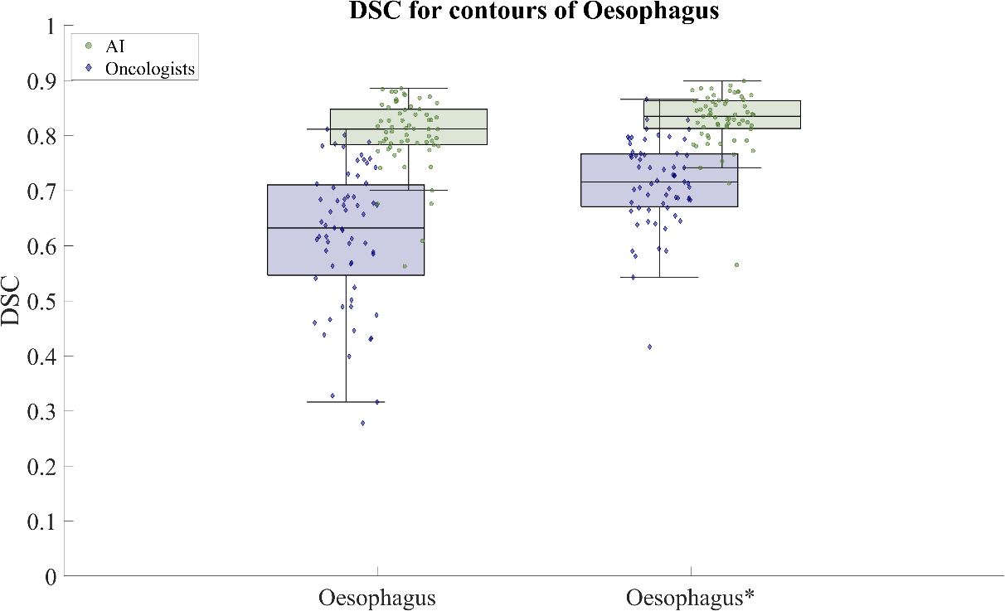
Supplementary figure 1: Dice Similarity Coefficient (DSC) for contours of Oesophagus. * indicates the oesophagus contours after correction to have the same caudal length.

Supplementary figure 2

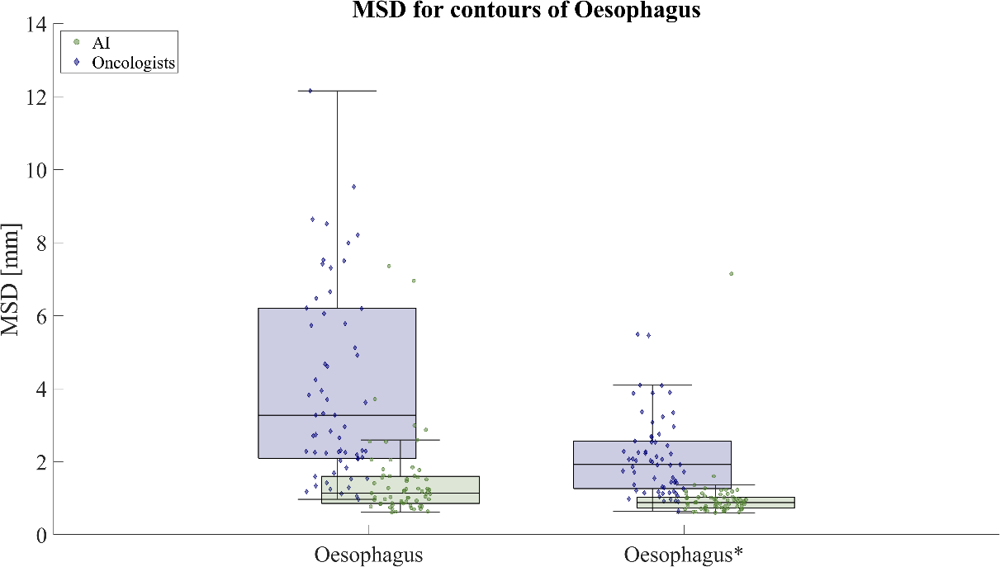
Supplementary figure 2: Mean Surface Distance (MSD) for contours of Oesophagus. * indicates the oesophagus contours after correction to have the same caudal length.

