Supplementary:

Model Characteristics

The L_{10%} (D > 54 Gy(RBE)) and L_{10%} (D > 50 Gy(RBE)) were included in two univariate linear regression models giving an estimated risk of brainstem necrosis. The parameters were chosen for the models based on correlation with toxicity from conditional logistic regression analysis. The models are given by the two following equations:

$${NTCP}_{54Gy(RBE)}= -0.02 \left[-0.13, 0.03\right]+0.03⋅L_{10\%} \left(D>54 Gy\left(RBE\right)\right) \left[0.00, 0.08\right] (A1)$$

$${NTCP}_{50Gy(RBE)}= 0.01 \left[-0.08, 0.03\right]+0.01⋅L_{10\%} \left(D>50 Gy\left(RBE\right)\right) \left[-0.00, 0.06\right] (A2)$$

The brackets in the equations show the confidence intervals in which the coefficients are defined. The data used to develop the models were in the ranges 2.33 to 3.80 keV/µm for the L_{10%} (D > 54 Gy(RBE)) and between 2.45 and 4.29 keV/µm for the L_{10%} (D > 50 Gy(RBE)). NTCP estimates for LET_{d}-values outside these ranges may therefore be unreliable and, due to the linearity of the model, there is a lower L_{10%}-threshold of applicablity for both models where the models will no longer output positive NTCP estimates.
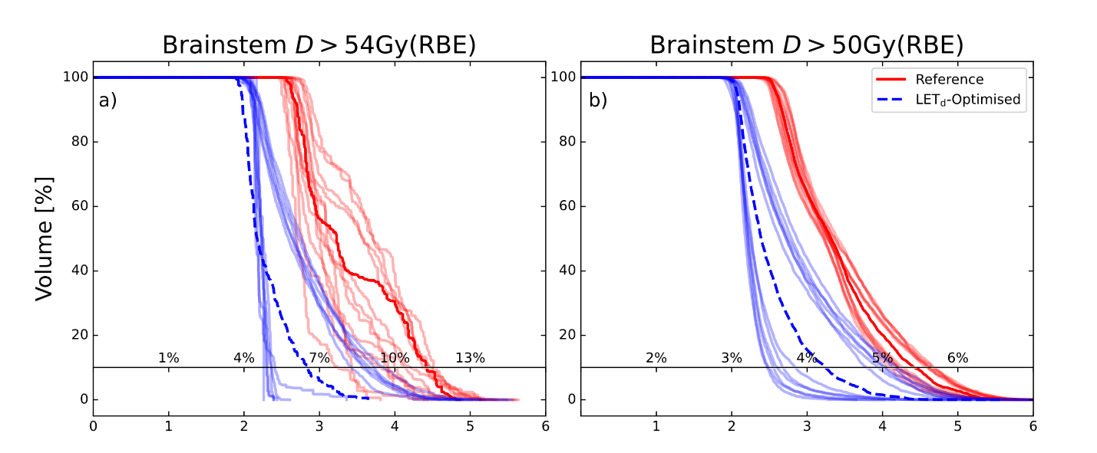
Figure A1: LET_{d}-distributions of the brainstem for an example patient in the cohort. Subfigure a) shows the LET_{d} in the subvolume of the brainstem receiving dose over 54 Gy(RBE) for the reference plan in red and the LET_{d}-optimised plan in blue with robustness scenarios shown as the slightly faded lines. Subfigure b) shows a similar figure except the brainstem volume receiving dose over 50 Gy(RBE) is shown instead.

Table A1: NTCP estimates, L_{10%} and the absolute volume of the brainstem volume receiving dose over 54 Gy(RBE) to the left and over 50 Gy(RBE) to the right for each patient. The values from the TOPAS simulated plans, the delivered plan recalculated in Raystation with best and worst case robustness scenarios, and LET_{d}-optimised plans with best and worst case robustness scenarios.
 |  | D > 54 Gy(RBE) |  |  | D > 50 Gy(RBE)
 |  | NTCP  [%] | L_{10%} [keV/µm] | Volume [cm³] | NTCP  [%] | L_{10%} [keV/µm] | Volume [cm³]
Patient 1 reference plan | TOPAS simulation | 10.3 [3.0, 19.8] | 4.1 | 0.26 | 5.0 [3.0, 16.1] | 4.01 | 7.79
Patient 1 reference plan | Nominal case | 11.3 [3.0, 22.4] | 4.43 | 0.27 | 5.4 [3.0, 18.5] | 4.42 | 8.20
Patient 1 reference plan | Worst case scenario | 11.5 [3.0, 23.1] | 4.51 | 0.57 | 5.7 [3.0, 20.1] | 4.68 | 10.08
Patient 1 reference plan | Best case scenario | 7.7 [3.0, 12.9] | 3.24 | 0.09 | 5.1 [3.0, 16.5] | 4.09 | 5.91
Patient 1 LET-optimised plan | Nominal  case | 6.5 [3.0, 9.7] | 2.84 | 0.27 | 4.2 [3.0, 11.4] | 3.24 | 8.08
Patient 1 LET-optimised plan | Worst case scenario | 9.5 [3.0, 17.8] | 3.85 | 8.27 | 5.2 [3.0, 17.2] | 4.19 | 10.30
Patient 1 LET-optimised plan | Best case scenario | 4.8 [3.0, 5.1] | 2.26 | 0.00 | 3.5 [3.0, 6.8] | 2.47 | 3.65
Patient 2 reference plan | TOPAS simulation | 6.7 [3.0, 10.2] | 2.9 | 0.81 | 3.8 [3.0, 8.6] | 2.77 | 13.56
Patient 2 reference plan | Nominal case | 7.3 [3.0, 11.8] | 3.10 | 0.56 | 3.9 [3.0, 9.6] | 2.94 | 13.45
Patient 2 reference plan | Worst case scenario | 7.8 [3.0, 13.0] | 3.25 | 1.54 | 4.2 [3.0, 10.9] | 3.15 | 12.35
Patient 2 reference plan | Best case scenario | 6.3 [3.0, 9.1] | 2.77 | 0.40 | 3.8 [3.0, 8.7] | 2.79 | 14.56
Patient 2 LET-optimised plan | Nominal case | 4.5 [3.0, 4.4] | 2.18 | 0.37 | 3.3 [3.0, 5.9] | 2.31 | 11.92
Patient 2 LET-optimised plan | Worst case scenario | 6.4 [3.0, 9.4] | 2.80 | 11.07 | 3.8 [3.0, 8.6] | 2.77 | 14.56
Patient 2 LET-optimised plan | Best case scenario | 3.8 [3.0, 2.4] | 1.92 | 0.00 | 3.0 [3.0, 4.0] | 2.00 | 8.39
Patient 3 reference plan | TOPAS simulation | 6.7 [3.0, 10.2] | 3.1 | 0.62 | 4.5 [3.0, 12.7] | 3.45 | 13.68
Patient 3 reference plan | Nominal case | 7.6 [3.0, 12.5] | 3.19 | 0.00 | 4.6 [3.0, 13.9] | 3.64 | 13.29
Patient 3 reference plan | Worst case scenario | 8.5 [3.0, 15.0] | 3.50 | 0.01 | 4.9 [3.0, 15.3] | 3.89 | 14.78
Patient 3 reference plan | Best case scenario | 5.3 [3.0, 6.3] | 2.42 | 0.00 | 4.4 [3.0, 12.2] | 3.37 | 11.51
Patient 3 LET-optimised plan | Nominal case | 3.4 [3.0, 1.5] | 1.81 | 0.00 | 3.3 [3.0, 5.8] | 2.30 | 11.09
Patient 3 LET-optimised plan | Worst case scenario | 7.3 [3.0, 11.7] | 3.09 | 12.79 | 4.5 [3.0, 12.8] | 3.47 | 14.35
Patient 3 LET-optimised plan | Best case scenario | 3.1 [3.0, 0.6] | 1.70 | 0.00 | 2.7 [3.0, 2.5] | 1.74 | 3.72
Patient 4 reference plan | TOPAS simulation | 9.4 [3.0, 17.4] | 3.8 | 0.38 | 4.7 [3.0, 14.4] | 3.74 | 4.79
Patient 4 reference plan | Nominal case | 10.3 [3.0, 19.7] | 4.09 | 0 | 5.1 [3.0, 16.4] | 4.06 | 4.75
Patient 4 reference plan | Worst case scenario | 13.1 [3.0, 27.2] | 5.03 | 0.05 | 5.2 [3.0, 17.4] | 4.23 | 6.01
Patient 4 reference plan | Best case scenario | 8.3 [3.0, 14.6] | 3.45 | 0.00 | 4.9 [3.0, 15.1] | 3.86 | 3.24
Patient 4 LET-optimised plan | Nominal case | -2.0 [3.0, -13.0] | 0.00 | 0.00 | 4.3 [3.0, 12.1] | 3.34 | 4.2
Patient 4 LET-optimised plan | Worst case scenario | 9.6 [3.0, 17.9] | 3.86 | 1.11 | 4.8 [3.0, 15.1] | 3.85 | 2.02
Patient 4 LET-optimised plan | Best case scenario | 4.8 [3.0, 5.3] | 2.28 | 0 | 4.0 [3.0, 10.1] | 3.01 | 4.85
Patient 5 reference plan | TOPAS simulation | 6.7 [3.0, 10.2] | 2.9 | 0.44 | 3.9 [3.0, 9.2] | 2.86 | 10.78
Patient 5 reference plan | Nominal case | 7.1 [3.0, 11.1] | 3.02 | 0.25 | 4.1 [3.0, 10.3] | 3.06 | 10.73
Patient 5 reference plan | Worst case scenario | 8.6 [3.0, 15.3] | 3.54 | 0.74 | 4.3 [3.0, 11.7] | 3.29 | 9.75
Patient 5 reference plan | Best case scenario | 6.3 [3.0, 9.0] | 2.75 | 0.07 | 3.9 [3.0, 9.5] | 2.92 | 11.52
Patient 5 LET-optimised plan | Nominal case | 5.7 [3.0, 7.5] | 2.56 | 0 | 3.4 [3.0, 6.6] | 2.43 | 9.39
Patient 5 LET-optimised plan | Worst case scenario | 6.8 [3.0, 10.4] | 2.92 | 3.67 | 3.8 [3.0, 8.9] | 2.82 | 12.56
Patient 5 LET-optimised plan | Best case scenario | 5.2 [3.0, 6.2] | 2.41 | 0 | 3.3 [3.0, 5.7] | 2.28 | 3.36
Patient 6  Reference plan | TOPAS simulation | 8.8 [3.0, 15.8] | 3.6 | 0.02 | 4.3 [3.0, 12.0] | 3.34 | 5.92
Patient 6  Reference plan | Nominal case | 7.4 [3.0, 12.1] | 3.14 | 0.02 | 4.5 [3.0, 13.0] | 3.51 | 5.62
Patient 6  Reference plan | Worst case scenario | 7.6 [3.0, 12.7] | 3.21 | 0.09 | 5.0 [3.0, 16.0] | 4.00 | 6.46
Patient 6  Reference plan | Best case scenario | 5.7 [3.0, 7.4] | 2.55 | 0 | 4.2 [3.0, 11.4] | 3.24 | 4.79
Patient 6 LET-optimised plan | Nominal case | 7.8 [3.0, 13.1] | 3.27 | 0.01 | 4.2 [3.0, 11.0] | 3.17 | 5.56
Patient 6 LET-optimised plan | Worst case scenario | 8.6 [3.0, 15.4] | 3.55 | 4.42 | 4.9 [3.0, 15.1] | 3.85 | 7.08
Patient 6 LET-optimised plan | Best case scenario | 7.7 [3.0, 12.8] | 3.22 | 0.00 | 3.7 [3.0, 8.0] | 2.66 | 2.60
Patient 7 reference plan | TOPAS | 10.0 [3.0, 19.0] | 4.0 | 3.34 | 5.2 [3.0, 17.4] | 4.24 | 8.16
Patient 7 reference plan | Nominal case | 10.7 [3.0, 20.9] | 4.24 | 3.81 | 5.6 [3.0, 19.8] | 4.63 | 8.38
Patient 7 reference plan | Worst case scenario | 11.7 [3.0, 23.6] | 4.57 | 4.77 | 5.9 [3.0, 21.5] | 4.92 | 10.05
Patient 7 reference plan | Best case scenario | 9.2 [3.0, 16.8] | 3.73 | 2.38 | 5.3 [3.0, 17.5] | 4.26 | 6.24
Patient 7 LET-optimised plan | Nominal case | 6.5 [3.0, 9.6] | 2.83 | 0.01 | 4.3 [3.0, 11.6] | 3.26 | 6.98
Patient 7 LET-optimised plan | Worst case scenario | 9.0 [3.0, 16.2] | 3.65 | 3.79 | 4.9 [3.0, 15.5] | 3.91 | 8.58
Patient 7 LET-optimised plan | Best case scenario | 5.7 [3.0, 7.6] | 2.58 | 0.00 | 3.9 [3.0, 9.4] | 2.90 | 3.36

