Supplementary Data
Supplementary Figure S1:
A)
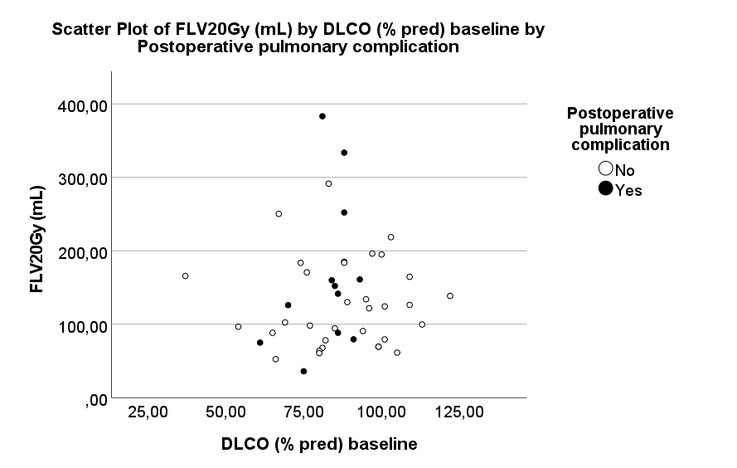

B)
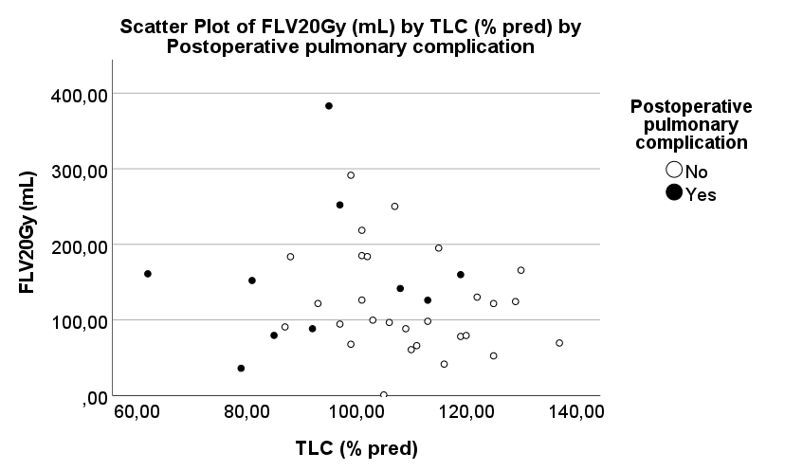

FLV20Gy(mL) = Functional lung volume (expressed in mL) exposed to 20 Gy; DLCO= diffusing capacity for carbon monoxide expressed as a percentage of the expected value; TLC (L) = Total lung capacity expressed as a percentage of the expected value.
Table S1: Dose-volume parameters of relative anatomical and functional long volumes
A)
 | Postoperative pulmonary complications
 | No (n= 39) |  |  | Yes (n=12)
 | Mean | SD |  | Mean | SD |  | p-value
ALV40Gy (rel) | ,01 |  | ,01 | ,02 |  | ,01 |  | ,111
FLV40Gy (rel) | ,02 |  | ,01 | ,02 |  | ,02 |  | 1,000
ALV30Gy (rel) | ,04 |  | ,03 | ,05 |  | ,03 |  | ,754
FLV30Gy (rel) | ,02 |  | ,01 | ,02 |  | ,02 |  | 1,000
ALV20Gy (rel) | ,16 |  | ,06 | ,18 |  | ,07 |  | ,179
FLV20Gy (rel) | ,19 |  | ,08 | ,19 |  | ,08 |  | ,472
ALV10Gy (rel) | ,37 |  | ,12 | ,39 |  | ,13 |  | ,326
FLV10Gy (rel) | ,42 |  | ,15 | ,42 |  | ,14 |  | ,483
ALV5Gy (rel) | ,57 |  | ,19 | ,57 |  | ,19 |  | ,491
FLV5Gy (rel) | ,63 |  | ,20 | ,59 |  | ,16 |  | ,273
B)
 | PTV volume (cc)
 | PCC | p
FLV10Gy(cc) | ,012 | ,934
FLV20Gy(cc) | -,016 | ,909

ALV = Anatomical lung volume; FLV = Functional lung volume; SD= Standard deviation; rel indicates the relative volume exposed to x Gy (absolute volume exposed to x Gy divided by the total ALV or FLV).
PCC= Pearson’s correlation coefficient: a positive PCC implies a decrease in pulmonary function versus a negative PCC that implies an increase in this pulmonary function.
p-value for significance <0,05

Table S2: Correlations (by Pearson correlation) between differences in pulmonary function tests before versus after neoadjuvant chemoradiotherapy and anatomical or functional lung volume dose-volume parameters.
 | ∆DLCO (% pred) |  | ∆Tiff (% pred)
 | PCC | p | PCC | p
Mean ALV dose | ,095 | ,315 | ,179 | ,117
Mean FLV dose | ,058 | ,385 | ,008 | ,478
ALV40Gy (rel) | -,117 | ,277 | ,100 | ,254
FLV40Gy (rel) | -,138 | ,242 | -,245 | ,050
ALV30Gy (rel) | ,067 | ,368 | ,106 | ,241
FLV30Gy (rel) | -,138 | ,242 | -,245 | ,050
ALV20Gy (rel) | ,082 | ,339 | ,117 | ,219
FLV20Gy (rel) | ,118 | ,275 | -,121 | ,212
ALV10Gy (rel) | ,057 | ,386 | ,188 | ,106
FLV10Gy (rel) | ,036 | ,428 | ,055 | ,357
ALV5Gy (rel) | ,052 | ,397 | ,188 | ,105
FLV5Gy (rel) | -,003 | ,495 | ,095 | ,265
ALV40Gy (cc) | -,063 | ,374 | ,065 | ,334
FLV40Gy (cc) | ,000 | ,499 | -,192 | ,100
ALV30Gy (cc) | ,041 | ,419 | ,118 | ,218
FLV30Gy (cc) | ,000 | ,499 | -,192 | ,100
ALV20Gy (cc) | ,077 | ,349 | ,137 | ,181
FLV20Gy (cc) | ,194 | ,161 | ,050 | ,371
ALV10Gy (cc) | ,043 | ,415 | ,176 | ,121
FLV10Gy (cc) | ,132 | ,251 | ,153 | ,155
ALV5Gy (cc) | ,041 | ,418 | ,184 | ,110
FLV5Gy (cc) | ,074 | ,354 | ,132 | ,191
DLCO= diffusing capacity for carbon monoxide; Tiff= Tiffeneau index as calculated by dividing forced expiratory volume in 1 second by vital capacity. ∆ quantifies the differences before versus after neoadjuvant chemoradiotherapy. p-value for significance <0,05.
ALV= Anatomical lung volume; FLV= Functional lung volume; cc quantifies the absolute volume that is exposed to x Gy whereas rel indicates the relative volume exposed to x Gy (absolute volume exposed to x Gy divided by the total ALV or FLV).
PCC= Pearson’s correlation coefficient: a positive PCC implies a decrease in pulmonary function versus a negative PCC that implies an increase in this pulmonary function.

Table S3: Correlations (by Pearson correlation) between pulmonary function tests and anatomical or functional lung volume.
 |  | ALV |  | FLV
 | N | PCC | p-value | PCC | p-value
FEV1 (% pred) baseline | 51 | -,050 | ,365 | ,080 | ,288
TLC (% pred) | 38 | ,342 | ,018 | -,186 | ,131
DLCO (% pred) baseline | 45 | -,038 | ,402 | ,027 | ,429
Tiff (% pred) baseline | 47 | -,220 | ,068 | ,004 | ,490

ALV= Anatomical lung volume; FLV= Functional lung volume; N= number of patients used in correlation analysis; PCC= Pearson’s correlation coefficient; p-value for significance <0,05.
FEV1= forced expiratory volume in 1 second; TLC= Total lung capacity; DLCO= diffusing capacity for carbon monoxide; Tiff= Tiffeneau index as calculated by FEV1 divided by vital capacity.
% pred quantifies the pulmonary function test in comparison with predicted normal values, based on a patient’s sex, height, age and race.
Negative values indicate an inverse relationship between ALV/FLV and a certain pulmonary function test.

