Supplemental material

Supplemental Table 1. Severity of COVID-19
Degree of severity | Description
1 | None to mild symptoms. No need for in-patient care.
2 | Requires in-patient care, but no need for supplemental oxygen.
3 | Requires in-patient care and supplemental oxygen.
4 | Requires in-patient care and non-invasive ventilation.
5 | Requires intensive care at ICU and/or ventilator for respiratory support.

Supplemental Table 2. Univariable analyses of clinical characteristics predicting anxiety versus. self-isolation.

 | Anxiety |  |  | Self-isolation
 | Number*  univariable analysis | OR  univariable analysis | p-value  univariable analysis | Number*  univariable analysis | OR  univariable analysis | p-value univariable analysis
Self-isolation
Strict vs  no/partial isolation | 598 | 2.80 (1.95, 4.06) | <0.001 | - | - | -
Anxiety
High vs no/mild | - | - | - | 598 | 2.80 (1.95, 4.06) | <0.001
Gender
Female vs  male | 599 | 3.49 (2.39, 5.18) | <0.001 | 602 | 1.64 (1.18, 2.27) | 0.003
Age
Continuous | 599 | 0.99 (0.98, 1.00) | 0.12 | 602 | 1.03 (1.02, 1.05) | <0.001
Type of malignancy
Solid vs hematological | 599 | 1.61 (1.05, 2.51) | 0.03 | 602 | 0.86 (0.58, 1.26) | 0.43
Treatment intention
Palliative vs curative | 599 | 0.80 (0.56, 1.15) | 0.22 | 602 | 1.09 (0.78, 1.53) | 0.61
Place of birth
Born in Europe | 598 | 0.79 (0.39, 1.49) | 0.48 | 601 | 1.26 (0.70, 2.32) | 0.44
Born outside Europe | 598 | 2.90 (1.35, 6.41) | 0.007 | 601 | 1.84 (0.84, 4.34) | 0.14

*The total number of patients used for calculations is based on the number of patients who completed this question regarding anxiety and self-isolation respectively in the questionnaire.

Supplemental Table 3. Clinical characteristics of patients stratified by their self-reported degree of anxiety and degree of self-isolation.
 | Anxiety |  |  | Self-isolation
 | None – mild | Intermediate – high | p-value | No | Yes | p-value
Total* n | 406 | 193 | - | 273 | 329 | -
Age, years
Mean (SD)) | 65.1 (12.6) | 63.4 (12.6) | 0.117 | 62.0 (12.6) | 66.8 (12.2) | <0.001
Gender
Male, n (%) | 209 (51.5) | 45 (23.3) | <0.001 | 134 (49.1) | 122 (37.1) | <0.001
Female, n (%) | 197 (48.5) | 148 (76.7) | <0.001 | 139 (50.9) | 207 (62.9) | <0.001
Treatment intention
Curative, n (%) | 131 (32.3) | 72 (37.3) | 0.260 | 95 (34.8) | 108 (32.8) | 0.672
Palliative, n (%) | 275 (67.7) | 121 (62.7) | 0.260 | 178 (65.2) | 221 (67.2) | 0.672
Place of birth
Born in Sweden, n (%) | 357 (88.1) | 164 (85.0) | 0.012 | 244 (89.4) | 280 (85.4) | 0.261
Born in Europe, n (%) | 36 (8.9) | 13 (6.7) | 0.012 | 20 (7.3) | 29 (8.8) | 0.261
Born outside of Europe, n (%) | 12 (3.0) | 16 (8.3) | 0.012 | 9 (3.3) | 19 (5.8) | 0.261
Degree of anxiety
None – mild, n (%) | - | - | - | 217 (79.4) | 192 (58.0) | <0.001
Intermediate – high, n (%) | - | - | - | 56 (20.6) | 137 (42.0) | <0.001
Self-isolation
No, n (%) | 217 (53.3) | 56 (29.0) | <0.001 | - | - | -
Yes, n (%) | 189 (46.7) | 137 (71.0) | <0.001 | - | - | -
* The number and percentages are calculated on the total number of patients responding to the questionnaire.

Supplemental Figure 1.

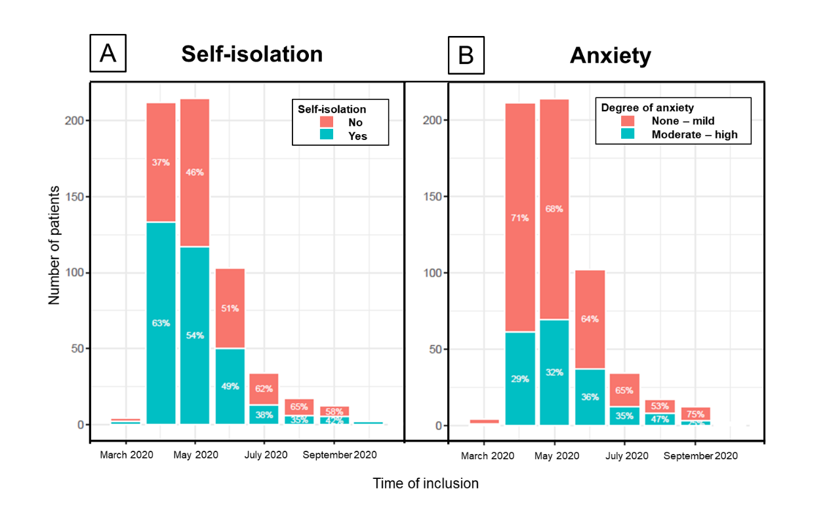
Supplemental Figure 1. Number of patients and the (A) degree of self-isolation (no vs. yes) and (B) self-reported degree of anxiety (none – mild vs. moderate – high, illustrated as percentage proportions at the time of inclusion and the variation through the inclusion period (April 1st – August 1st). No significant difference in degree of either self-isolation or anxiety was observed.

Supplemental Figure 2.
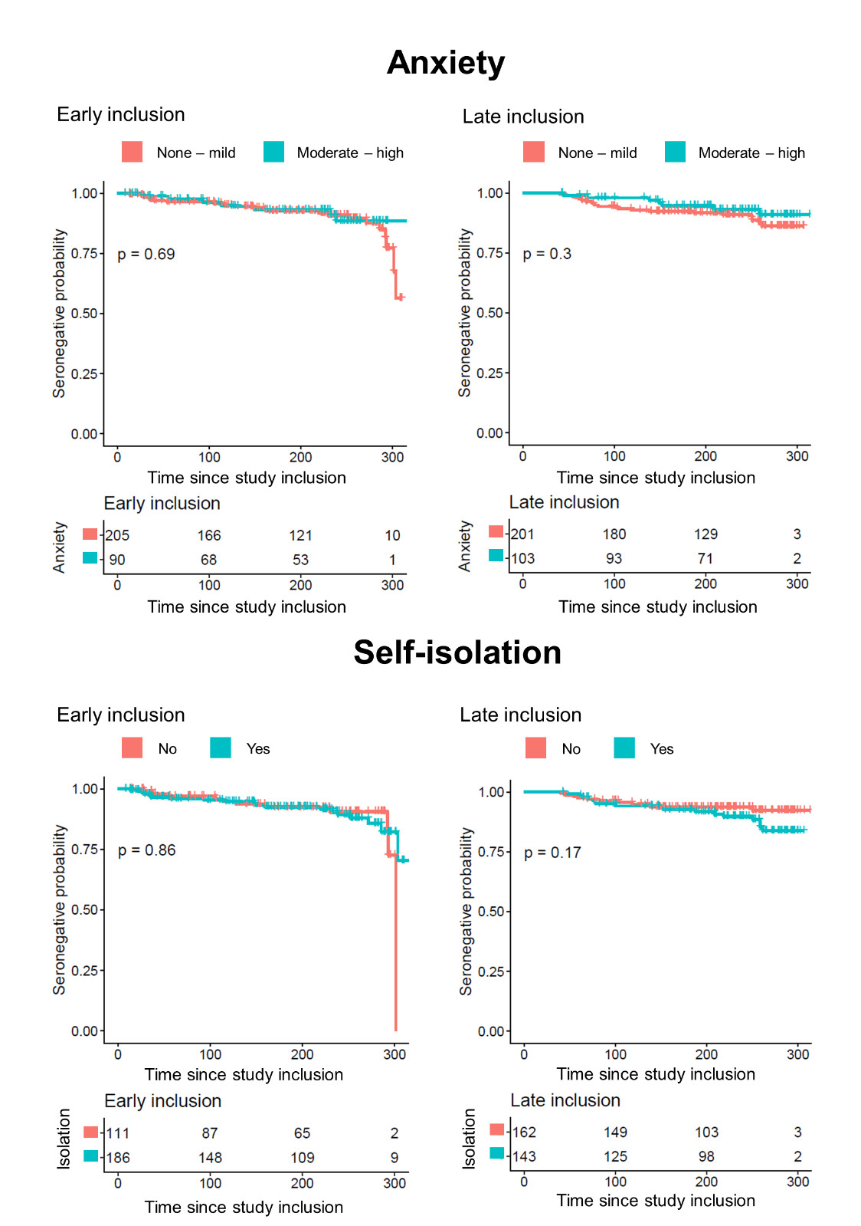
Supplemental Figure 2. Kaplan-Meier curves illustrating how the rate of seropositivity varied depending on degree of anxiety or self-isolation stratified by when study participants were included in the study; early inclusion (April 1st – May 11th) versus late inclusion (May 12th – August 1st). No significant difference in outcome was found.

Patient questionnaire
Study participants were given a questionnaire at the time of inclusion in the study. Questions focused on the participants’ current work- and home life, degree of COVID-19-related anxiety and degree of self-isolation.
- Date of birth □□□□

- Country of birth?
  - Sweden
  - Within Europe
  - Outside Europe

- Do you live alone?
  - Yes
  - No, with the presence of minors
  - No, with a partner
  - No, with a partner and minors
  - No, with another adult
  - No, with another adult and children

- Have you self-isolated since the COVID-19 pandemic began?
  - No, I have not changed the way I live my life
  - Yes, completely, except for health-care visits
  - Partly, I go to the store and visit friends

- What degree of education have you completed? Mark the highest form of fully completed or ongoing education
  - Elementary school
  - Upper secondary school
  - University
  - Other:_______________________________________________

- What is your current occupation? Several alternatives are allowed
  - Pensioner
  - Work full-time
  - Work part-time
  - Student
  - Seeking employment
  - Sick-leave / Disability pensioner
  - Other: _______________________________________________

- If you are working, what is your current work situation? Several alternatives are allowed
  - At home
  - At my regular place of work where I see <10 persons every day
  - At my regular place of work where I see <10 persons every day
  - Other: _______________________________________________

- Do you experience anxiety or fear related to COVID-19-infection and disease?
  - None
  - Little
  - Quite a lot
  - A lot

- We are not able to ask about everything in a questionnaire. Do you have any other views or would like to elaborate a response? ________________________________________________________________________________________________________________________________________________________________________________________________________________________________________________________________________________________________________________________________________________________________

