Table S1. List of studies excluded due to non-reporting of cutaneous adverse events
No. | Non-reporting of cutaneous adverse events
1 | Dahlén T, Edgren G, Ljungman P et al. Adverse outcomes in chronic myeloid leukemia patients treated with tyrosine kinase inhibitors: Follow-up of patients diagnosed 2002–2017 in a complete coverage and nationwide agnostic register study. Am J Hematol. 2022;97(4):421-430.
2 | Szeto AH, Bucci T, Deal A et al. Response to tyrosine kinase inhibitors in real-world patients with chronic myeloid leukemia. Ann Pharmacother. 2022;56(7):753-763.
3 | Scalzulli E, Caocci G, Efficace F et al. Real-life comparison of nilotinib versus dasatinib as second-line therapy in chronic phase chronic myeloid leukemia patients. Ann Hematol. 2021;100(5):1213-1219.
4 | Canet J, Cony-Makhoul P, Orazio S et al. Second- or third-generation tyrosine kinase inhibitors in first-line treatment of chronic myeloid leukemia in general population: Is there a real benefit? Cancer Med. 2021;10(20):6959-6970.
5 | Seo HY, Ko TH, Hyun SY et al. Tyrosine kinase inhibitor dosing patterns in elderly patients with chronic myeloid leukemia. Clin Lymphoma Myeloma Leuk. 2019;19(11):735-743.e2.
6 | Nakazato T, Iriyama N, Tokuhira M et al. Incidence and outcome of second malignancies in patients with chronic myeloid leukemia during treatment with tyrosine kinase inhibitors. Med Oncol. 2018;35(7):99.
7 | Rossi AR, Breccia M, Abruzzese E et al. Outcome of 82 chronic myeloid leukemia patients treated with nilotinib or dasatinib after failure of two prior tyrosine kinase inhibitors. Haematologica. 2013;98(3):399-403.
8 | Kantarjian H, O’ Brien S, Jabbour E et al. Impact of treatment end point definitions on perceived differences in long-term outcome with tyrosine kinase inhibitor therapy in chronic myeloid leukemia. J Clin Oncol. 2011;29(23):3173-8.

(A)
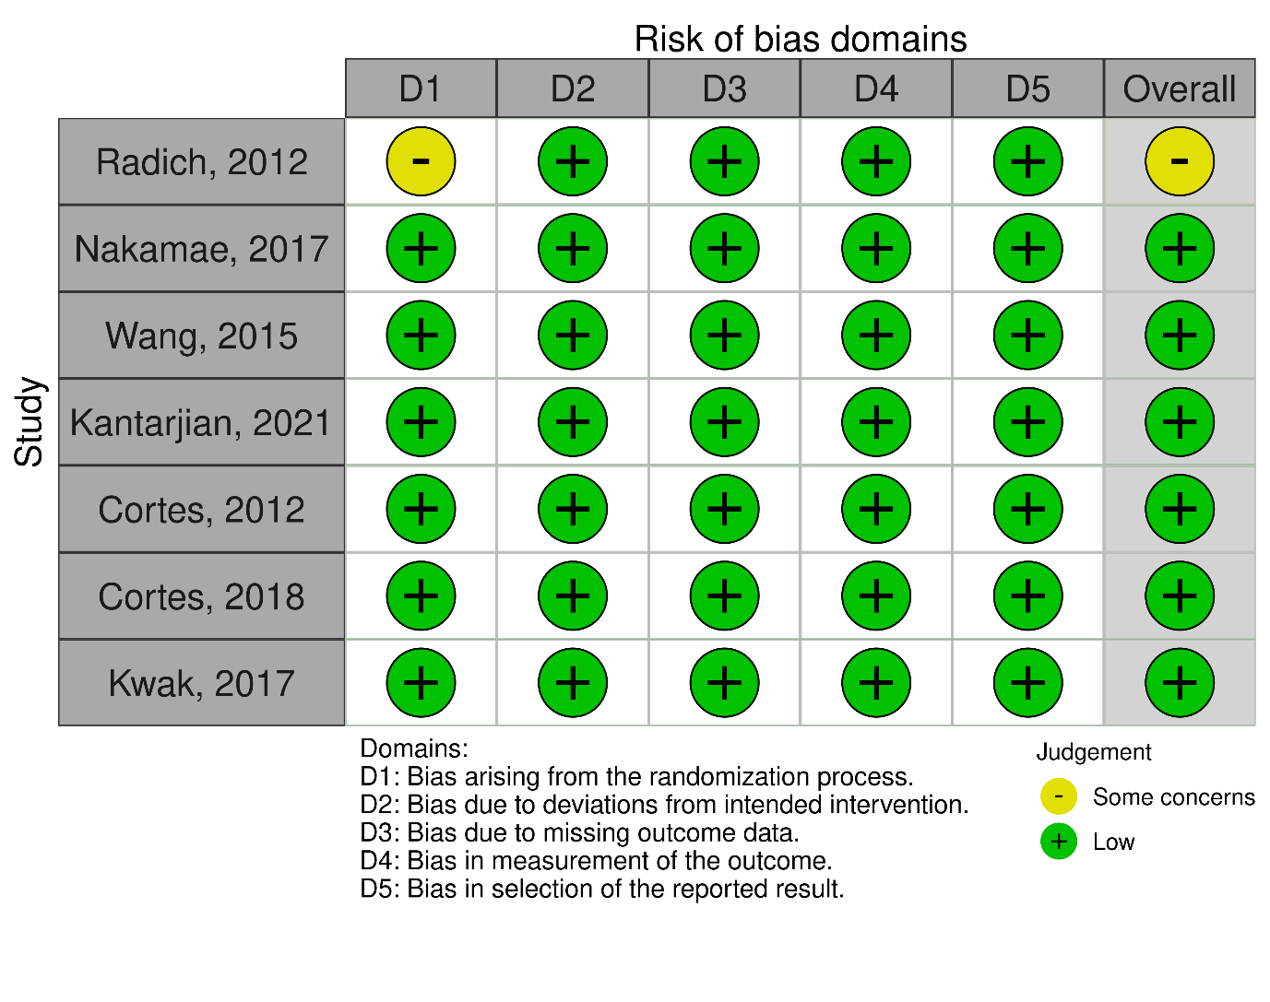
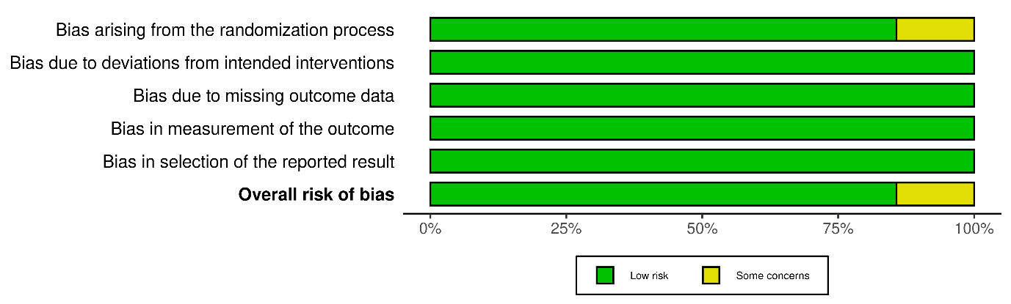

(B)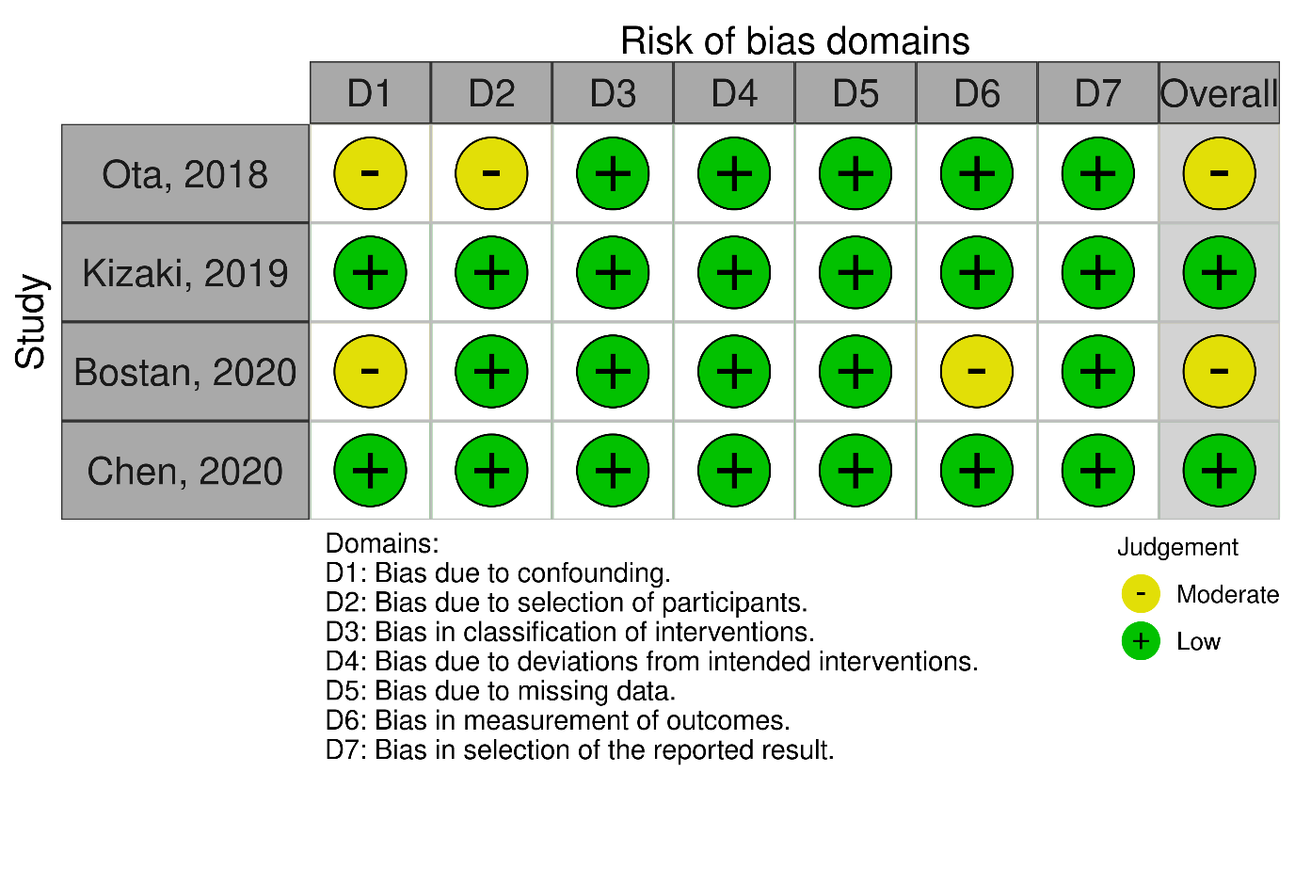
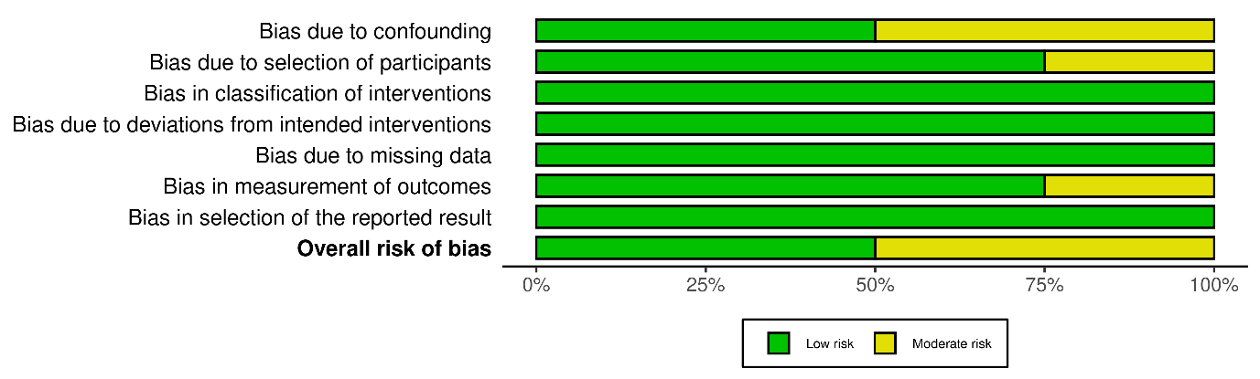

Figure S1. Risk of bias assessment of (A) randomized controlled trials (RCTs) and (B) non-RCTs

Table S2. Information on permanent discontinuation of TKI treatment due to cutaneous AEs
Study | Permanent TKI discontinuation due to cutaneous AEs | Note
Radich, 2012 | Not reported | Treatment discontinuation was occurred due to toxicity or refusal, but there was no information that it was due to cutaneous AEs.
Nakamae, 2017 | Not reported | There were cases of treatment discontinuation due to AEs, but there was no information that these were due to cutaneous AEs.
Ota, 2018 | Not reported | Treatment discontinuation was occurred due to treatment failure or progression.
Kizaki, 2019 | Not reported | There were cases of treatment discontinuation due to AEs, but there was no information that these were due to cutaneous AEs.
Bostan, 2020 | Not reported | No information is available regarding the treatment discontinuation.
Wang, 2015 | Not reported | There were cases of treatment discontinuation due to AEs, but there was no information that these were due to cutaneous AEs.
Kantarjian, 2021 | Not reported | No information is available regarding treatment discontinuation.
Chen, 2020 | Not reported | There were cases of treatment discontinuation due to AEs, but there was no information that these were due to cutaneous AEs.
Cortes, 2012 | Reported | In the bosutinib group, a patient discontinued the treatment due to a rash.
Cortes, 2018 | Not reported | There were cases of treatment discontinuation due to AEs, but there was no information that these were due to cutaneous AEs.
Kwak, 2017 | Not reported | There were cases of treatment discontinuation due to AEs, but there was no information that these were due to cutaneous AEs.
Lipton, 2016 | Not reported | There were cases of treatment discontinuation due to AEs, but there was no information that these were due to cutaneous AEs.
Abbreviation: AEs, adverse events; TKI, tyrosine kinase inhibitors.

(A)
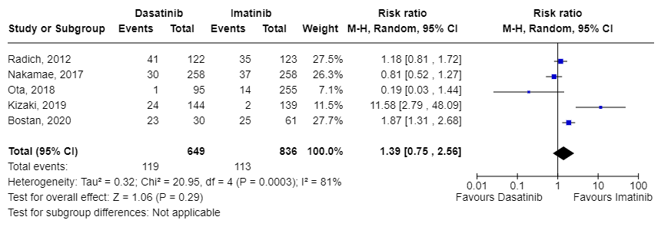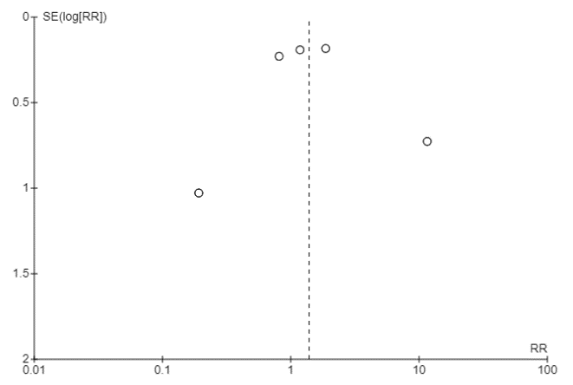

(B)
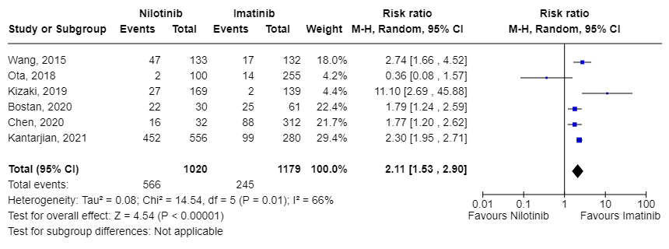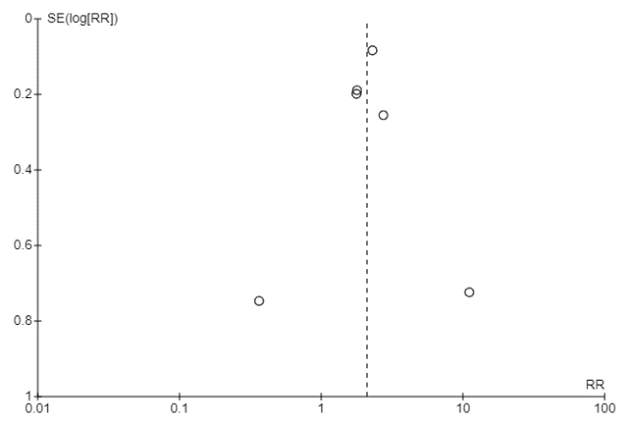

(C)
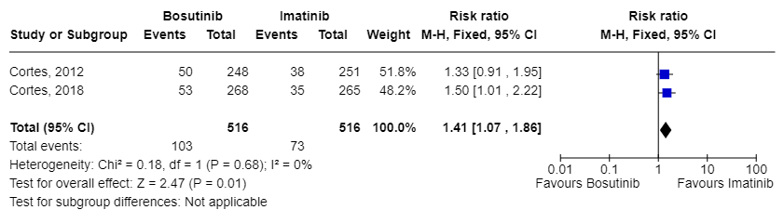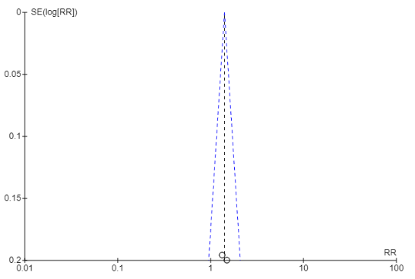

(D)
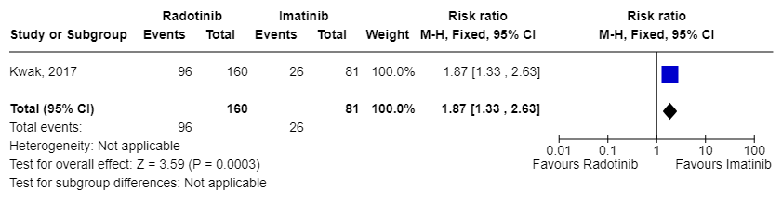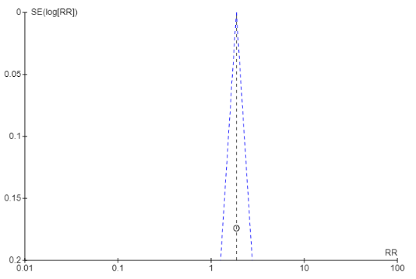

Figure S2. Forest plots of meta-analysis for the relative risk of all-grades cutaneous adverse events in patients with CML treated with (A) dasatinib, (B) nilotinib, (C) bosutinib, or (D) radotinib compared to those with imatinib

(A)
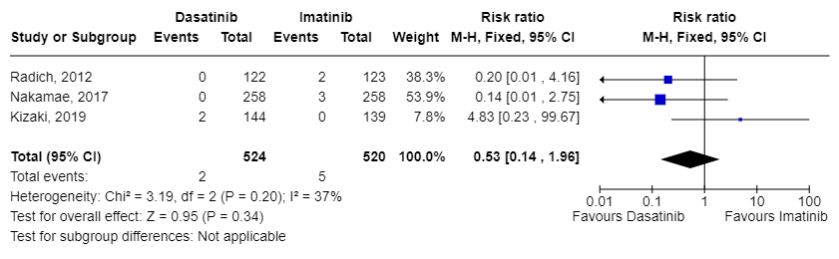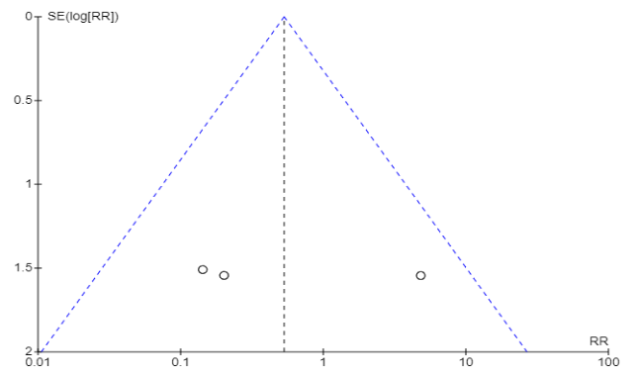

(B)
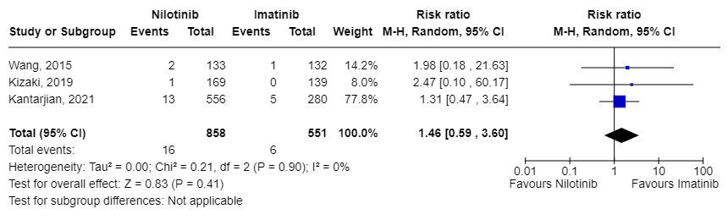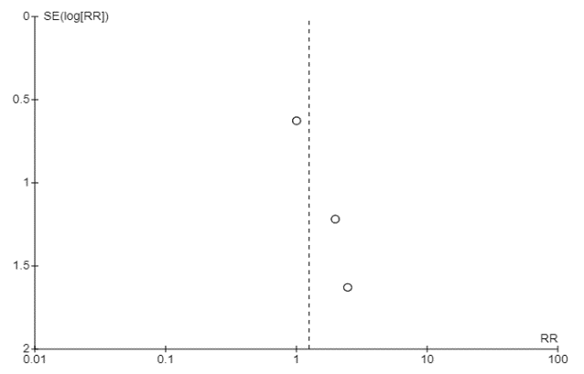

(C)
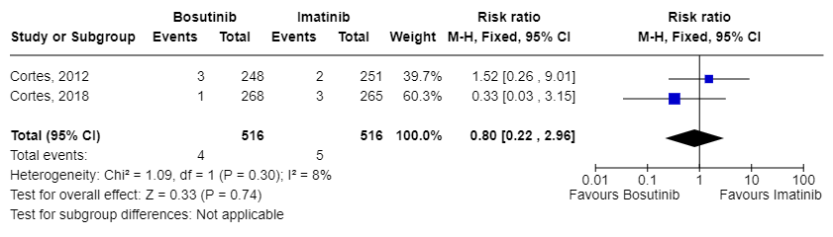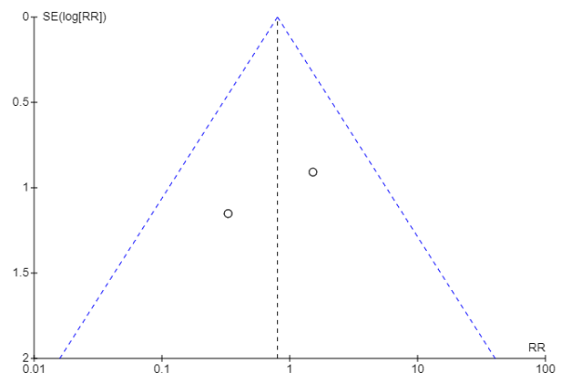

(D)
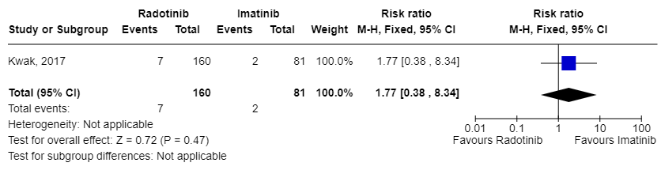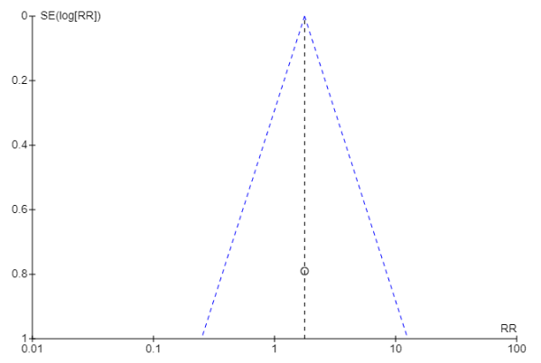

Figure S3. Forest plots of meta-analysis for the relative risk of grade ≥3 cutaneous adverse events in patients with CML treated with (A) dasatinib, (B) nilotinib, (C) bosutinib, or (D) radotinib compared to those with imatinib

(A)
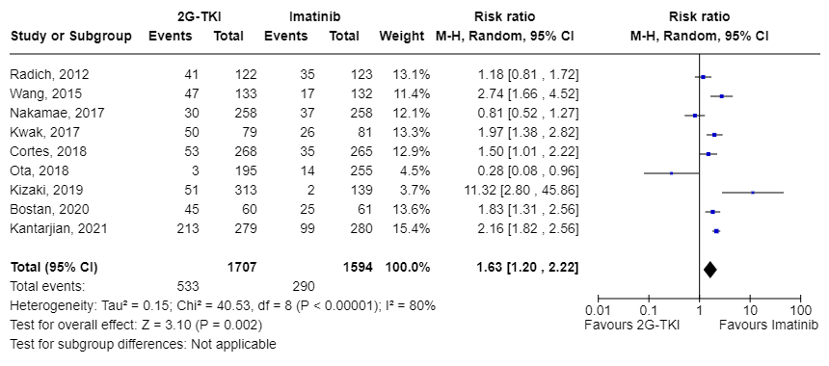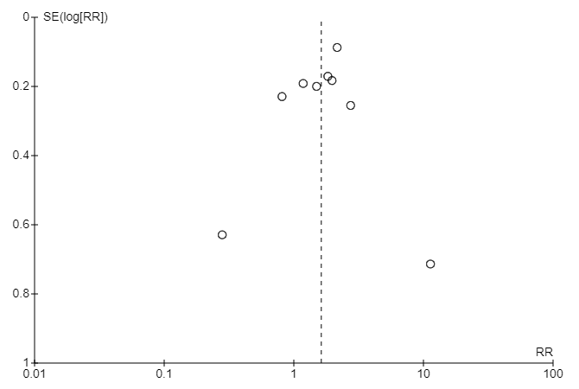
(B)
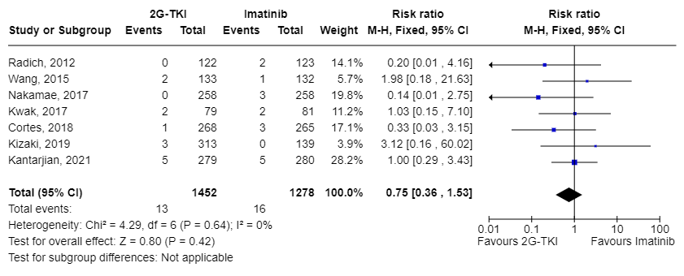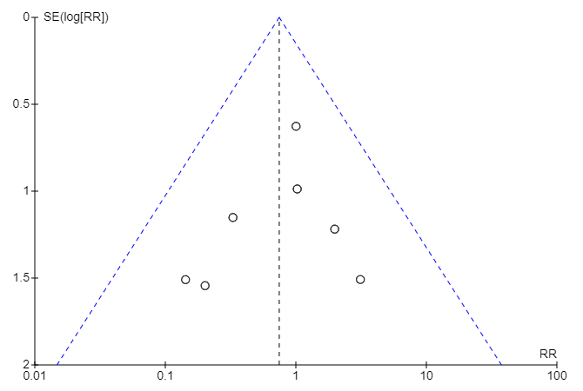
Figure S4. Post-hoc meta-analysis for the relative risk of (A) all grades and (B) grade ≥3 cutaneous adverse events between second-generation tyrosine kinase inhibitors (2G-TKIs) and imatinib for studies in which standard dosage of TKIs was used as first-line in patients with CML

