Supplemental Figure 1: Diagnostic delay (A) and no. of ALK+ NSCLC patients diagnoses/year (B). Horizontal red bar (A) denotes the median diagnostic delay.

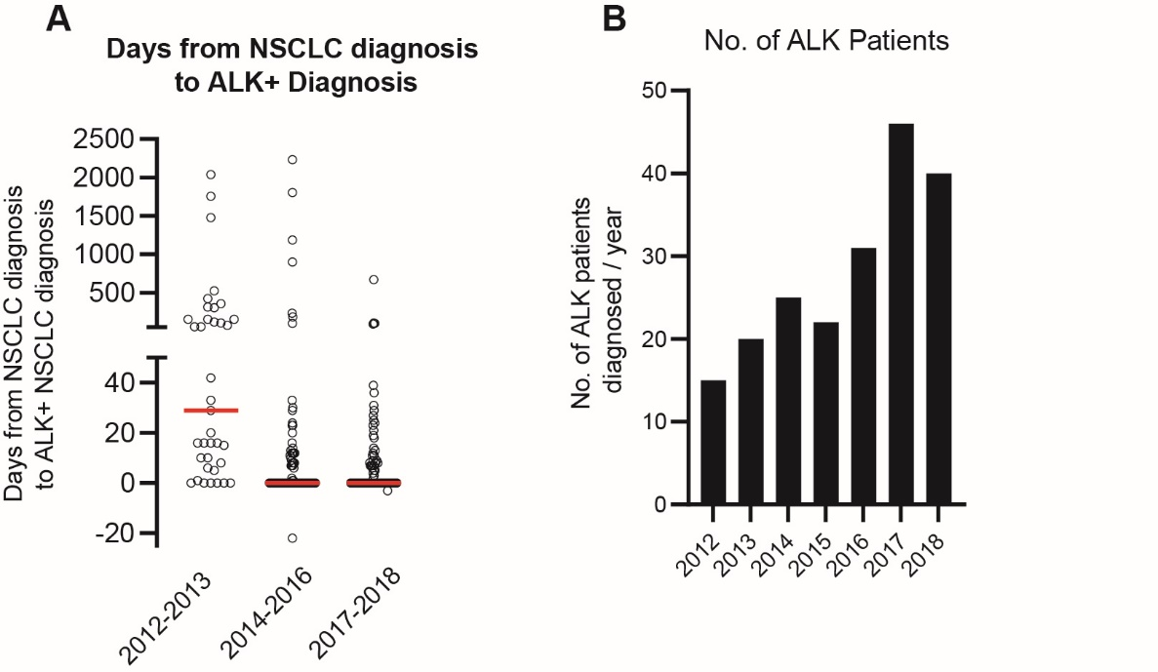

Supplemental Figure 2: Treatment pattern of stage Ia-IIIaALK+ NSCLC patients. Inner circle represents 1st line treatment, middle circle represents 2nd line treatment, and outer circle represents 3rd line treatment. n represents the number of patients treated in 1st line.
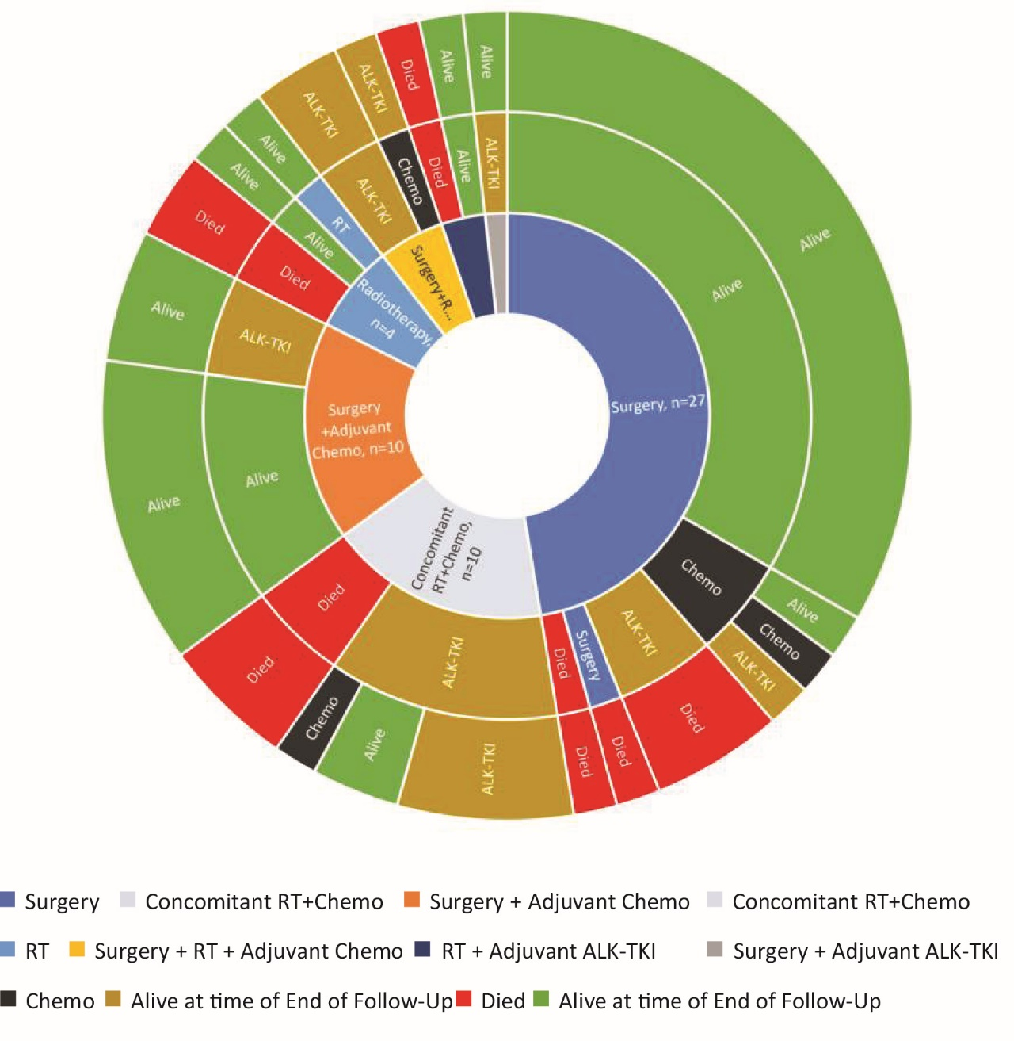

Supplemental Figure 3: Treatment pattern of stage IIIb-IVb ALK+ NSCLC patients. Inner circle represents 1st line treatment, middle circle represents 2nd line treatment, and outer circle represents 3rd line treatment. Hashed areas: treatment with lorlatinib (1), erlotinib (2), dabrafenib (1), and Nivolumab (1). n represents the number of patients treated in 1st line.

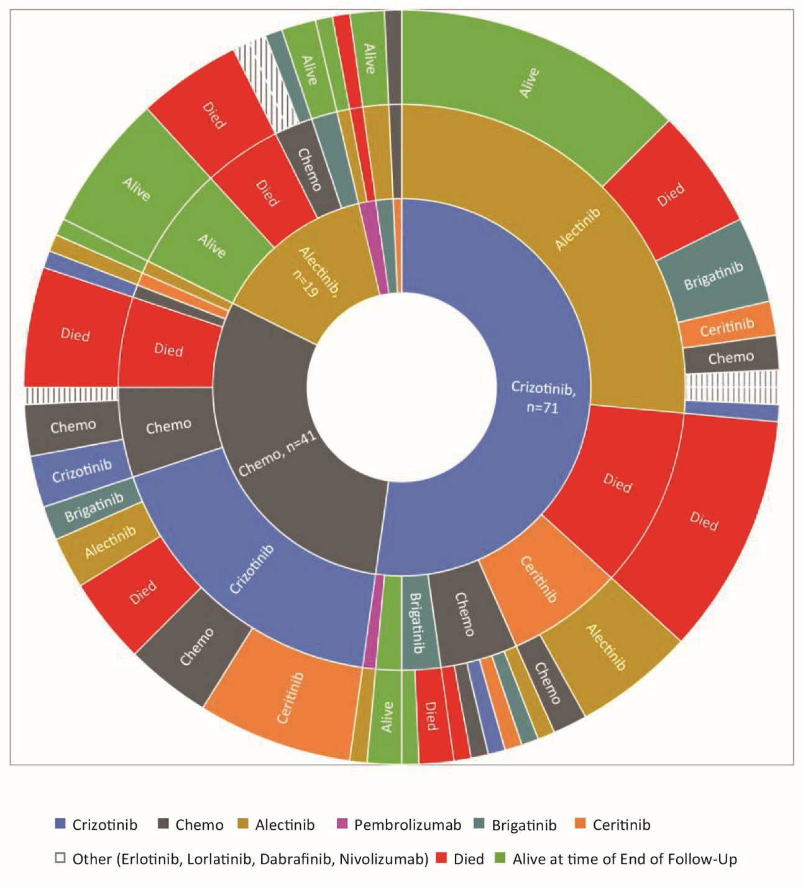

Supplemental Table 1: fractions of patients diagnosed with brain metastasis.
Year | ALK+ diagnoses | Brain Mets at diagnosis | % of patients with brain mets at diagnosis
2018 | 40 | 8 | 20
2017 | 46 | 5 | 11
2016 | 31 | 3 | 10
2015 | 22 | 2 | 9
2014 | 25 | 2 | 8
2013 | 20 | 1 | 5
2012 | 15 | 0 | 0
2011 | 1 | 0 | 0

Supplemental table 2: detailed description of treatment patterns for stage I-IIIa ALK+ NSCLC patients.
1st line | N | 2nd line | N | 3rd line | N
Surgery | 27 | Alive | 19 | Alive | 19
 |  | Died | 1 | Died | 1
 |  | Surgery | 1 | Died | 1
 |  | ALK-TKI | 3 | Died | 3
 |  | Chemo | 3 | ALK-TKI | 1
 |  |  |  | Chemo | 1
 |  |  |  | Alive | 1
Surgery+Adjuvant Chemo | 10 | ALK-TKI | 3 | Alive | 3
 |  | Alive | 7 | Alive | 7
Surgery+Adjuvant ALK-TKI | 1 | ALK-TKI | 1 | Alive | 1
Surgery+RT+Adjuvant Chemo | 3 | Chemo | 1 | ALK-TKI | 1
 |  | ALK-TKI | 2 | ALK-TKI | 2
Radiotherapy | 4 | Died | 2 | Died | 2
 |  | RT | 1 | Alive | 1
 |  | Alive | 1 | Alive | 1
Concomitant RT+Chemo | 10 | ALK-TKI | 7 | ALK-TKI | 4
 |  |  |  | Chemo | 1
 |  |  |  | Alive | 2
 |  | Died | 3 | Died | 3
Concomitant RT + ALK-TKI | 2 | Alive | 1 | Alive | 1
 |  | Died | 1 | Died | 1

Supplemental Table 3: detailed description of treatment patterns for advanced stage ALK+ NSCLC patients.
1st line | N | 2nd line | N | 3rd line | N
Chemo | 41 | Died | 7 | Died | 7
 |  | Chemo | 7 | Chemo | 3
 |  |  |  | Erlotinib | 1
 |  |  |  | Crizotinib | 3
 |  | Crizotinib | 24 | No Treatment | 5
 |  |  |  | Chemo | 5
 |  |  |  | Ceritinib | 9
 |  |  |  | Alectinib | 3
 |  |  |  | Brigatinib | 2
 |  | Alectinib | 1 | Alive | 1
 |  | Ceritinib | 1 | Alectinib | 1
 |  | Avestin | 1 | Crizotinib | 1
Crizotinib | 71 | Died | 14 | Died | 14
 |  | Alive | 2 | Alive | 2
 |  | Chemo | 6 | Died | 1
 |  |  |  | Chemo | 1
 |  |  |  | Crizotinib | 1
 |  |  |  | Ceritinib | 1
 |  |  |  | Brigatinib | 1
 |  |  |  | Alectinib | 1
 |  | Alectinib | 36 | Died | 7
 |  |  |  | Alive | 17
 |  |  |  | Chemo | 2
 |  |  |  | Crizotinib | 1
 |  |  |  | Ceritinib | 2
 |  |  |  | Brigatinib | 5
 |  |  |  | Lorlatinib | 1
 |  |  |  | Erlotinib | 1
 |  | Ceritinib | 9 | Chemo | 2
 |  |  |  | Alectinib | 7
 |  | Brigatinib | 3 | Died | 2
 |  |  |  | Alive | 1
 |  | Pembrolizumab | 1 | Alectinib | 1
Alectinib | 19 | Died | 6 | Died | 6
 |  | Alive | 8 | Alive | 8
 |  | Chemo | 3 | Brigatinib | 1
 |  |  |  | Nivo | 1
 |  |  |  | Other (dabrafenib) | 1
 |  | Brigatinib | 2 | Alive | 2
Brigatinib | 2 | Alectinib | 2 | Alive | 2
Ceritinib | 1 | Chemo | 1 | Chemo | 1
Pembrolizumab | 2 | Died | 1 | Died | 1
 |  | Alectinib | 1 | Alive | 1

Supplemental Table 4: treatment length of ALK-TKIs. All data in months. NA: No patient received this treatment. NIL: Only one patient received this therapy. *: following chemotherapy.
Treatment Length for patients who did not receive chemotherapy in 1st line. All data in Months
NA: no patients received this ALK-TKI in this line of treatment. NIL: only one patient received crizotinib
Line of treatment | All ALK-TKI |  |  |  |  |  |  |  |  |  |  |  | Crizotinib |  |  |  |  |  |  |  |  |  |  |  | Later Generations
Line of treatment | Mean |  | SD |  | Median |  | Min |  | Max |  | N |  | Mean |  | SD |  | Median |  | Min |  | Max |  | N |  | Mean |  | SD |  | Median |  | Min |  | Max |  | N
1st | 12.6 |  | 10.08 |  | 9.12 |  | 0.6 |  | 36.6 |  | 99 |  | 11.28 |  | 9.12 |  | 8.64 |  | 0.6 |  | 35.52 |  | 74 |  | 16.56 |  | 11.64 |  | 25.08 |  | 1.2 |  | 36.6 |  | 25
2nd | 15.96 |  | 12.48 |  | 18.6 |  | 0.24 |  | 49.2 |  | 52 |  | NA |  | NA |  | NA |  | NA |  | NA |  | 0 |  | 15.96 |  | 12.48 |  | 18.6 |  | 0.24 |  | 49.2 |  | 52
3rd | 10.08 |  | 9.6 |  | 18.24 |  | 0.84 |  | 28.44 |  | 16 |  | 23.16 |  | NIL |  | 23.16 |  | 23.16 |  | 23.16 |  | 1 |  | 9.24 |  | 9.24 |  | 18.24 |  | 0.84 |  | 28.44 |  | 15
4th | 7.8 |  | 6.48 |  | 9.6 |  | 1.8 |  | 15.84 |  | 4 |  | NA |  | NA |  | NA |  | NA |  | NA |  | 0 |  | 7.8 |  | 6.48 |  | 9.6 |  | 1.8 |  | 15.84 |  | 4
Treatment Length for patients who received chemotherapy in 1st line. All data in Months
NA: no patients received this ALK-TKI in this line of treatment. NIL: only one patient received crizotinib. *: following chemotherapy
Line of treatment following chemotherapy |  | All ALK-TKI |  |  |  |  |  |  |  |  |  |  |  | Crizotinib |  |  |  |  |  |  |  |  |  |  |  | Later Generations
 |  | Mean |  | SD |  | Median |  | Min |  | Max |  | N |  | Mean |  | SD |  | Median |  | Min |  | Max |  | N |  | Mean |  | SD |  | Median |  | Min |  | Max |  | N
1st |  | 17.52 |  | 19.56 |  | 12.6 |  | 2.4 |  | 93.6 |  | 40 |  | 17.28 |  | 21.48 |  | 9.84 |  | 0.24 |  | 93.6 |  | 31 |  | 18.72 |  | 11.76 |  | NR |  | 1.8 |  | 34.32 |  | 9
2nd |  | 18.36 |  | 16.8 |  | 16.08 |  | 2.04 |  | 57.12 |  | 23 |  | 33.72 |  | 33.12 |  | 10.44 |  | 10.44 |  | 57.12 |  | 2 |  | 16.92 |  | 15.12 |  | 16.08 |  | 2.04 |  | 55.44 |  | 21
3rd |  | 10.44 |  | 10.2 |  | 13.92 |  | 1.68 |  | 37.8 |  | 11 |  | NA |  | NA |  | NA |  | NA |  | NA |  | 0 |  | 10.44 |  | 10.2 |  | 13.92 |  | 1.68 |  | 37.8 |  | 11
4th |  | 4.2 |  | 4.08 |  | 5.64 |  | 0.72 |  | 9.84 |  | 4 |  | NA |  | NA |  | NA |  | NA |  | NA |  | 0 |  | 4.2 |  | 4.08 |  | 5.64 |  | 0.72 |  | 9.84 |  | 4

Supplemental Table 5: treatment length of ALK-TKIs. All data in years. NA: No patient received this treatment. NIL: Only one patient received this therapy. *: following chemotherapy.
Treatment Length for patients who did not receive chemotherapy in 1st line. All data in Years
NA: no patients received this ALK-TKI in this line of treatment. NIL: only one patient received crizotinib
Line of treatment | All ALK-TKI |  |  |  |  |  |  | Crizotinib |  |  |  |  |  | Later Generations
Line of treatment | Mean |  | SD | Median | Min | Max | N | Mean | SD | Median | Min | Max | N | Mean | SD | Median | Min | Max | N
1st | 1.05 |  | 0.84 | 0.76 | 0.05 | 3.05 | 99 | 0.94 | 0.76 | 0.72 | 0.05 | 2.96 | 74 | 1.38 | 0.97 | 2.09 | 0.10 | 3.05 | 25
2nd | 1.33 |  | 1.04 | 1.55 | 0.02 | 4.10 | 52 | NA | NA | NA | NA | NA | 0 | 1.33 | 1.04 | 1.55 | 0.02 | 4.10 | 52
3rd | 0.84 |  | 0.80 | 1.52 | 0.07 | 2.37 | 16 | 1.93 | NIL | 1.93 | 1.93 | 1.93 | 1 | 0.77 | 0.77 | 1.52 | 0.07 | 2.37 | 15
4th | 0.65 |  | 0.54 | 0.80 | 0.15 | 1.32 | 4 | NA | NA | NA | NA | NA | 0 | 0.65 | 0.54 | 0.80 | 0.15 | 1.32 | 4
Treatment Length for patients who received chemotherapy in 1st line. All data in Years
NA: no patients received this ALK-TKI in this line of treatment. NIL: only one patient received crizotinib. *: following chemotherapy
Line of treatment following chemotherapy |  | All ALK-TKI |  |  |  |  |  | Crizotinib |  |  |  |  |  | Later Generations
 |  | Mean | SD | Median | Min | Max | N | Mean | SD | Median | Min | Max | N | Mean | SD | Median | Min | Max | N
1st |  | 1.46 | 1.63 | 1.05 | 0..2 | 7.8 | 40 | 1.44 | 1.79 | 0.82 | 0.02 | 7.8 | 31 | 1.56 | 0.98 | NR | 0.15 | 2.86 | 9
2nd |  | 1.53 | 1.40 | 1.34 | 0.17 | 4.76 | 23 | 2.81 | 2.76 | 0.87 | 0.87 | 4.76 | 2 | 1.41 | 1.26 | 1.34 | 0.17 | 4.62 | 21
3rd |  | 0.87 | 0.85 | 1.16 | 0.14 | 3.15 | 11 | NA | NA | NA | NA | NA | 0 | 0.87 | 0.85 | 1.16 | 0.14 | 3.15 | 11
4th |  | 0.35 | 0.34 | 0.47 | 0.06 | 0.82 | 4 | NA | NA | NA | NA | NA | 0 | 0.35 | 0.34 | 0.47 | 0.06 | 0.82 | 4

Supplemental Table 6: Number and fractions of stage IIIb-IVb patients discontinuing treatments with chemotherapy, crizotinib, or 2nd generation ALK-TKIs. Statistical test for differences in distribution was performed using Chi2-test and did not find a statistically significant differences in patients discontinuing treatment due to toxicity, p = 0.082.
Treatment | Chemotherapy | Crizotinib | 2nd Gen ALK-TKI
Treatments Given in line 1 through 3, N | 74 | 101 | 113
Discontinuation due to toxicity, n (%) | 8 (10.8) | 11 (10.9) | 4 (3.5)

