**Supplementary figure 1.** Risk of prostate cancer death for men in Prostate Cancer data Base Sweden 5 with localized high-risk prostate cancer treated with radical radiotherapy according to type of radiotherapy and neoadjuvant and adjuvant therapy (**6 combinations of adjuvant suppression therapy**)

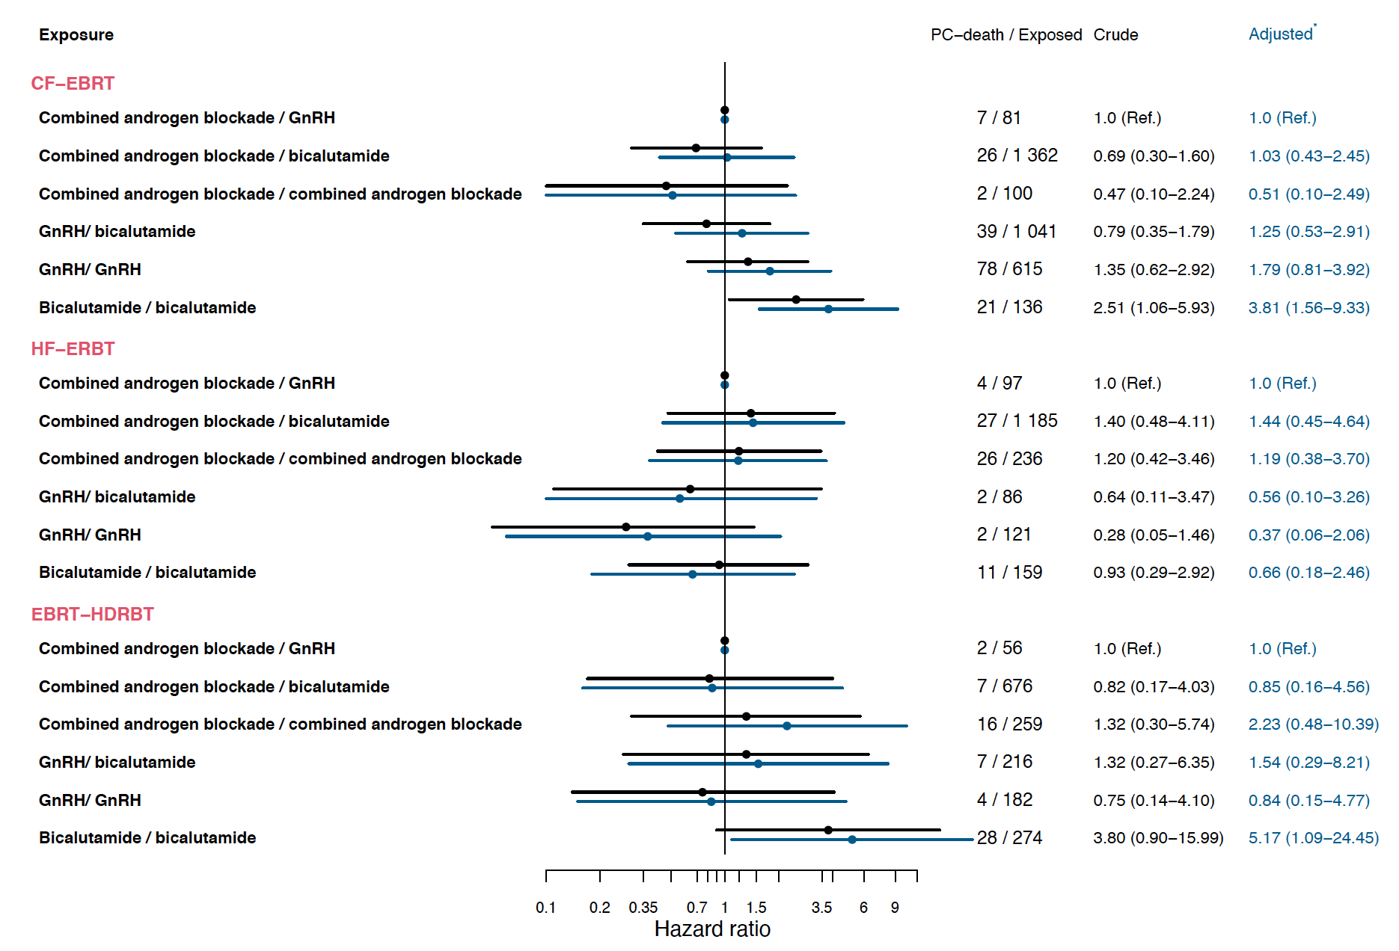

* Model including age at date of radiotherapy, local clinical T stage, N stage, Gleason score, PSA at diagnosis, percentage of positive cores, year of radiotherapy, duration of adjuvant treatment, CCI, educational level and civil status.

**Abbreviations**: CF-EBRT: conventionally fractionated external beam radiotherapy; HF-EBRT: hypofractionated external beam radiotherapy; EBRT-HDRBT external beam radiotherapy combined with high-dose brachytherapy boost

Hazard ratio **greater** than one favors reference group.

For men treated with CF-EBRT, there was no increased risk of Pca death for CAB/bicalutamide (HR: 1.03, 95% CI: 0.43-2.45) versus the reference CAB/GnRH. Risk of Pca death was increased for men receiving bicalutamide/bicalutamide (HR: 3.81, 95% CI: 1.56-9.33) versus CAB/GnRH.

For men treated with HF-EBRT, there was no increased risk of Pca death for CAB/bicalutamide (HR: 1.44, 95% CI: 0.45-4.64) or bicalutamide/bicalutamide (HR: 0.66, 95% CI: 0.18-2.46) versus CAB/GnRH.

For men treated with EBRT-HDRBT, there was no increased risk of Pca death for CAB/bicalutamide (HR: 0.85, 95% CI: 0.16-4.56) versus the reference CAB/GnRH. Risk of Pca death was increased for men receiving bicalutamide/bicalutamide (HR: 5.17, 95% CI: 1.09-24.45) versus CAB/GnRH.”