The dose-dependent impact of γ-radiation reinforced with backscatter from titanium on primary human osteoblasts
Supplemental material
Lisa Printzell^{1*}, Janne Elin Reseland², Nina Frederike Jeppesen Edin³, Hanna Tiainen²,
Jan Eirik Ellingsen¹

¹Department of Prosthodontics, Institute of Clinical Dentistry, Faculty for Dentistry, University of Oslo, Oslo, Norway
²Department of Biomaterials, Institute of Clinical Dentistry, Faculty for Dentistry, University of Oslo, Oslo, Norway
³Department of Physics, Faculty of Mathematics and Natural Science, University of Oslo, Oslo, Norway

*Corresponding author: lisa.printzell@odont.uio.no

Table of contents
Lactate dehydrogenase activity S3
Figure S1 S3
Concentrations osteogenic biomarkers S4
Figure S2. S4

Lactate dehydrogenase activity

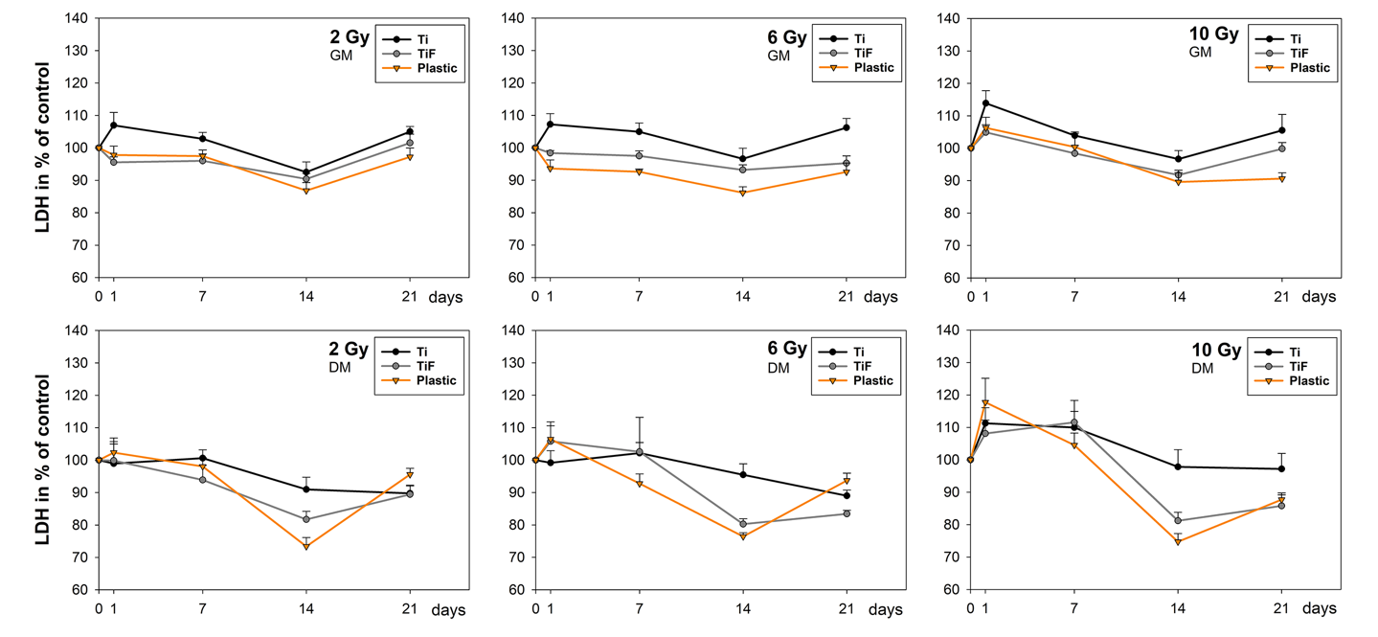
Figure S1. Temporal changes in LDH activity measured in the cell-culture medium at day 1, 7, 14 and 21 post-irradiation.

Concentrations osteogenic biomarkers

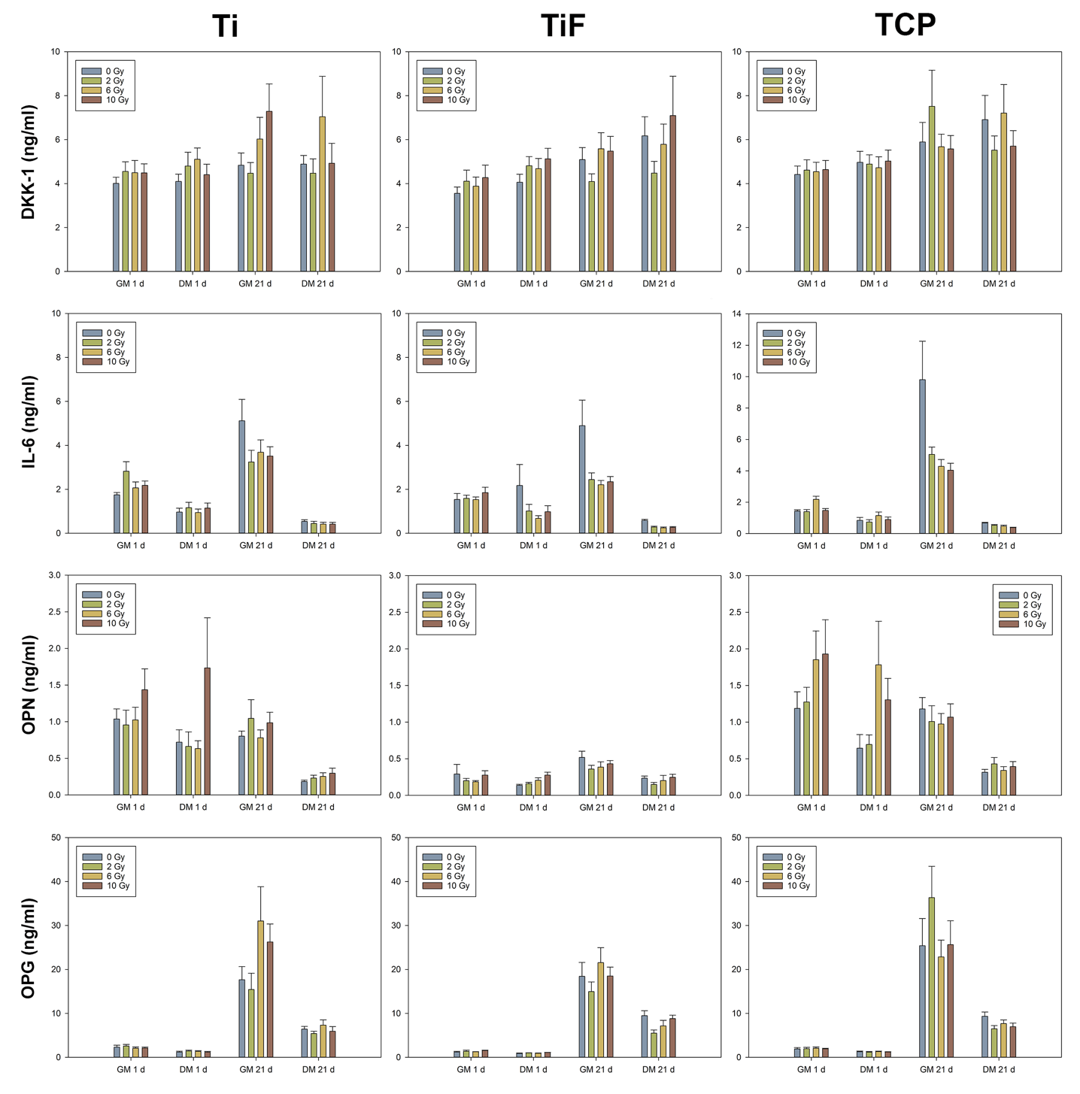
Figure S2. Concentrations of osteogenic biomarkers measured in the cell-culture medium at day 1 and 21 post-irradiation.

